

Requirement & Design Specification

Project Management System(PMS)

**Version: 1.0**

– Hanoi, August 2022 –

# Record of Changes

| **Version** | **Date** | **A* M, D** | **In charge** | **Change Description** |
| --- | --- | --- | --- | --- |
| v1.0 | 22/9 | A | DatND | III. System Design |
| v1.0 | 22/9 | A | DatND | II.1.1 Dashboard |
| v1.0 | 22/9 | A | DatND | II.1.2 User Profile + Password Change |
| v1.0 | 22/9 | A | MinhPN | III.1.3 User detail + User List |
| v1.0 | 22/9 | A | DatND | I.1. Context diagrams |
| v1.0 | 22/9 | A | DatND | I.2.1. UseCase diagrams |
| v1.0 | 22/9 | A | MinhPN | I.3.1. Screen flow |
| v1.0 | 23/9 | A | NghiaNM | II.1.1. Login |
| v1.0 | 23/9 | A | NghiaNM | II.1.2. Reset Password |
| v1.0 | 23/9 | A | NghiaNM | II.1.3. Register |
| v1.0 | 23/9 | A | TruongVV | II.2.4 Group List+Group Detail |
| v1.0 | 23/9 | A | AnhNQ | II.2.1.+.2. SettingList, SettingDetails |
| v1.0 | 10/10 | A | AnhNQ | I.2.4 UCs for PMO Manager |
| v1.0 | 10/10 | A | AnhNQ | I.2.5 UCs Project Manager |
| v1.0 | 10/10 | A | AnhNQ | I.2.6 Project QA |
| v1.0 | 14/10 | A | DatND | II.3.1. Project Evaluation |
| v1.0 | 14/10 | A | DatND | II.3.3. Project Member |
| v1.0 | 14/10 | A | DatND | II.3.4. Project Team List + Details |
| v1.0 | 14/10 | A | TruongVV | II.3.5. Project List |
| v1.0 | 14/10 | A | TruongVV | II.3.6. Project Details |
| v1.0 | 14/10 | A | AnhNQ | II.3.2. Project Milestone + Details |
| v1.1 | 14/10 | M | DatND | I.2.3. UCs Description |
| v1.1 | 14/10 | M | DatND | III.1. Database Design |
| v1.1 | 14/10 | M | NghiaNM | IV. 4.2 Phase List |
| v1.1 | 14/10 | M | NghiaNM | IV.4.3 Phase Details |
| v1.0 | 14/10 | A | NghiaNM | IV. 4.4 Criteria details |
| v1.1 | 14/10 | M | MinhPN | IV. 4 Domain User |
| v1.1 | 14/10 | M | MinhPN | IV. 4.1 Domain Details |
| v1.1 | 14/10 | M | MinhPN | IV. 4.1 Domain Criteria |
| v1.1 | 31/10 | M | DatND | I.2.1 + .2 + .3 UCs for Guest, Member, Admin |
| v1.1 | 3/11 | M | AnhNQ | I.2.2.3 UCs Description |
| v1.1 | 4/11 | A | NghiaNM | Defect List |
| v1.1 | 4/11 | A | NghiaNM | Defect Add |
| v1.1 | 4/11 | A | NghiaNm | Defect Detail |
| v1.0 | 4/11 | A | AnhNQ | I.2.4.3 Project Manager Features Workflow |
| v1.0 | 4/11 | A | AnhNQ | I.2.4.2 System Administration Workflow |
| v1.0 | 4/11 | A | AnhNQ | II.6 Project issue |
| v1.1 | 4/11 | M | DatND | I.1: System context. |
| v1.1 | 4/11 | M | DatND | I.2.1: Actors.. |
| v1.0 | 4/11 | A | DatND | I.2.4.1 User Authentication workflow |
| v1.1 | 4/11 | M | AnhNQ | I.2.2.2 UCs for Member |
| v1.1 | 4/11 | M | AnhNQ | I.2.2.5 UCs for PMO Manager |
| v1.1 | 4/11 | M | AnhNQ | I.2.2.6 UCs for ProjectQA |
| v1.1 | 4/11 | M | AnhNQ | I.2.2.7 UCs for Project Manager |
| v1.1 | 4/11 | M | AnhNQ | I.3.2 Screen Authorization |
| v1.1 | 4/11 | M | DatND | I.1 System Context |
| v1.1 | 4/11 | M | DatND | I.2.1. Actors |
| v1.0 | 4/11 | A | AnhNQ | I.2.4.5. Issue workflow |
| v1.1 | 4/11 | A | MinhPN | I.2.4.6. Domain workflow |
| v1.1 | 4/11 | M | MinhPN | I.2.3. Description |
| v1.1 | 4/11 | M | MinhPN | I.3.2. Screen Authorization |
| v1.1 | 4/11 | M | MinhPN | I.3.1. Screen Flow |
| v1.0 | 4/11 | A | DatND | II.5.1. Allocation List + Details |
| v1.0 | 4/11 | A | DatND | I.2.2.3. UCs for Team Lead |
| v1.1 | 6/11 | M | AnhNQ | I.2.2.5 UCs for PMO Manager |
| v1.1 | 6/11 | M | AnhNQ | I.2.2.6 UCs for ProjectQA |
| v1.1 | 6/11 | M | AnhNQ | I.2.2.7 UCs for Project Manager |
| v1.1 | 6/11 | M | AnhNQ | I.1. Context diagrams |

*A - Added M - Modified D - Deleted

Contents

Record of Changes 2

I. Overview 7

1. System Context 7

2. User Requirements 8

2.1 Actors 8

2.2 Diagrams 10

2.2.1 UCs for Guest 10

2.3 Descriptions 17

2.4 Main Workflows 19

3. System Functionalities 25

3.1 Screens Flow 25

3.2 Screen Authorization 26

3.3 Non-UI Functions 28

II. Functional Requirements 28

1. User Features 28

1.1 Login 28

1.2 Forgot password 29

1.3 Register 33

1.4 Dashboard 34

1.5 User Profile + Password change 34

2. System Administration 36

2.1 Setting List 36

2.2 Setting Details 37

2.3 User List + User Details 38

2.4 GroupList + Group Details 39

3. Project Manager Features 43

3.1. Project Evaluation 43

3.2. Project Milestone 44

3.3. Project Member 47

3.4. Project Team List + Details 48

3.5. Project List 51

3.6. Project Detail 51

4. Project QA Features 52

4.1. Domain User 52

4.2. Domain Setting 54

4.3. Domain criteria 55

4.4. Project Phase 57

4.4.2 Project Phase Detail 58

5. Department Manager Features 59

5.1. Allocation List + Details 59

6. Member Feature 61

6.1. Project Issue 61

6.1.2 New Issue 62

6.1.3 Issue Details 62

6.2. Project Defect 63

6.3. Defect New 64

6.4. Defect Detail 65

6.5. Requirement 66

6.6. Timesheet 67

6.6.1 Timesheet List 67

6.6.2 Timesheet detail 69

III. System Design 71

1. Database Design 71

1.1 Database Schema 71

1.2 Table Descriptions 71

2. Code Packages 74

2.1 Package Diagram 74

2.2 Package Descriptions 75

# I. Overview

## 1. System Context

The Project Management System (PMS) is designed to assist organizations in managing their projects information online. The system provides a framework for managing project milestones, teams, resources, and evaluations. It interacts with various external actors and subsystems to manage the flow of information, data, and project resources.

**Context Diagram**: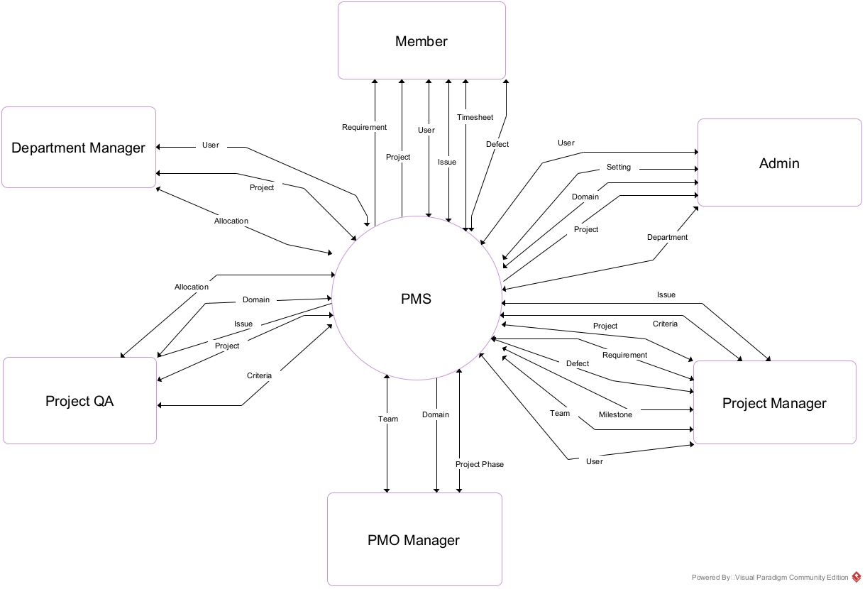

This diagram illustrates the interactions between the system and external entities, including project members, administrators (Admin). External entities interact with the system through interfaces such as User information, Project, Setting, Group.

**External actors and their interactions with the system**:

* **Members**: Report issues and log work hours via timesheets.
* **Project manager**: manage the details of the projects as created/assigned, mainly focus on: Project milestones, teams, requirements and project configs.
* **Department manager**: the manager of department in the company, responsible for

o Allocating his/her department resource to the projects as arranged by the project QA

o Creating new, monitoring & controlling his/her department’s projects

* **Project QA**: Project QA: responsible for the projects in his/her assigned domain

o Setting up new project, evaluation criteria, and project allocation

o Monitor and control details of the created/assigned projects

* **PMO Manager**: responsible for setting up general configs for the projects in that domain and the domain itself.
* **Admin**: the organization leader/manager, acts as the system administrator.

## 2. User Requirements

### 2.1 Actors

**Actors and their roles**:  
 This section provides a detailed description of the external actors interacting with the Project Management System (PMS). Actors can be individuals or external systems, and they play the role of providing or requesting services from the system. Each actor has specific responsibilities in the overall workflow of the system.

Below are the key actors and their roles in the system:

* **Administrator (Admin)**:  
   The Admin is responsible for managing the entire system, including system configuration, user access permissions, and resolving system issues. The Admin ensures the system operates smoothly and is well-maintained.
* **Members**: Members are employees of the company, they act as system users, they get to update their profiles information, view their assigned projects and login, logout.
* **Guest:** Guest can login or register, Guest can reset Guest’s password.

|  | **Actor** | **Description** |
| --- | --- | --- |
| 1 | Admin | The Admin is responsible for managing the system, configuring settings, and assigning user access. |
| 2 | Guest | Users outside the system. |
| 3 | Member | Member is an employee of the company that works on projects. |
| 4 | Team Leader | Team leader is a member that got the leader role in a team in a project. |
| 5 | Project Manager | Project manager is responsible for configuring the project he/she manages. |
| 6 | Project QA | Project QA is responsible for the quality of allocated projects, creating new projects and managing domain configs. |
| 7 | Department Manager | Department manager is responsible for allocating members in projects and managing allocated projects. |
| 8 | PMO Manager | Act as manager of Project QA and Department Manager, responsible for setting up general configs for the projects in that domain and the domains. |

### 

### 

### 

### 2.2 Diagrams

### 2.2.1 UCs for Guest

#### 

#### 

#### 2.2.2 UCs for Member

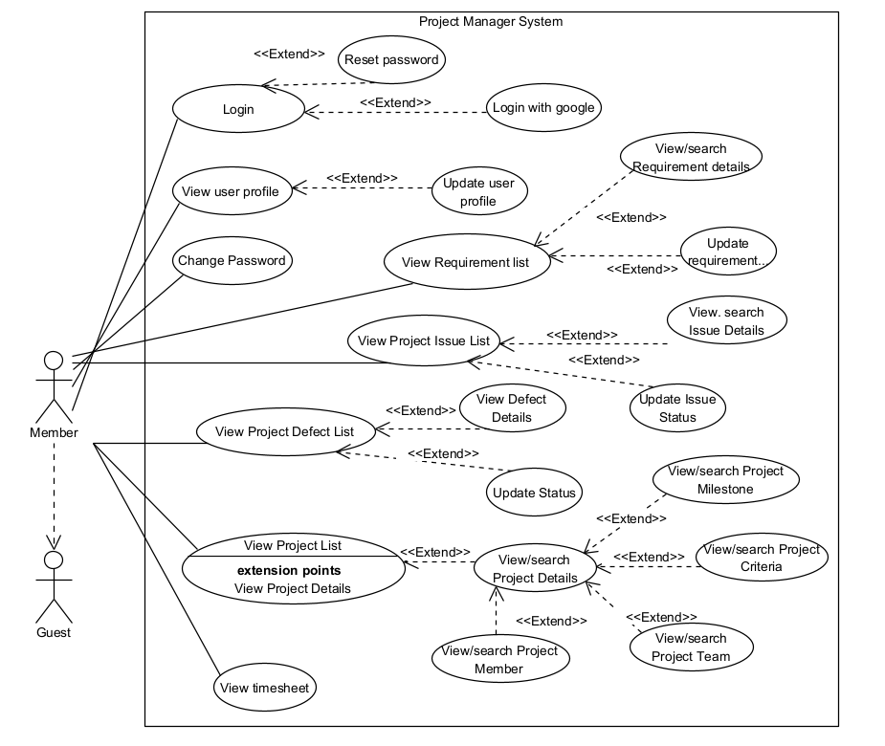

#### 

#### 2.2.3 UCs for Team Lead

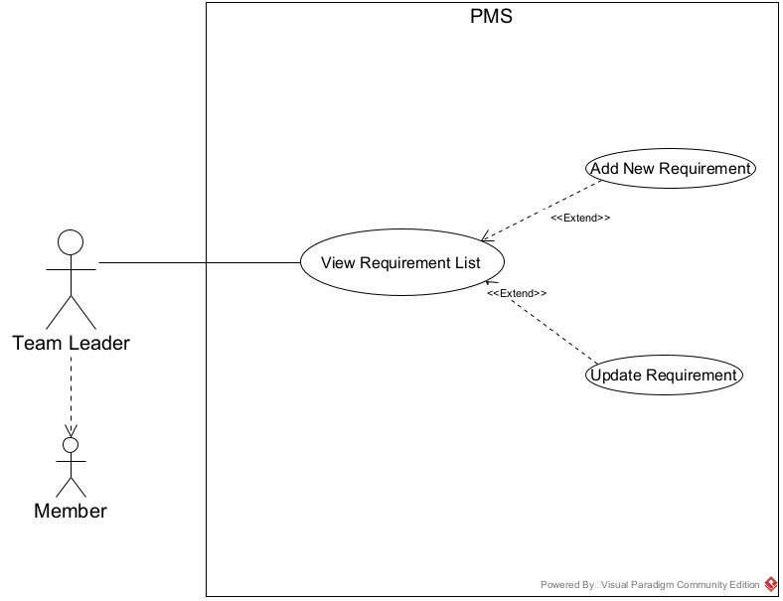

#### 2.2.4 UCs for Project Manager

#### 

#### 

#### 

#### 

#### 

#### 

#### 

#### 

#### 

#### 

#### 

#### 

#### 2.2.5 UCs for Project QA

#### 

#### 2.2.6 UCs for PMO Manager

#### 

#### 2.2.7 UCs for Admin

#### 

#### 

#### 

#### 

#### 

#### 

#### 

#### 

#### 

#### 

#### 

#### 

#### 

### 2.3 Descriptions

| **ID** | **Use Case** | **Actors** | **Use Case Description** |
| --- | --- | --- | --- |
| 01 | User Login | All Actors | All actors need to log into the system. The use case includes the option for "Forgot Password". |
| 02 | User register | Guest | Guest can register a new account |
| 03 | User List | Admin | Project Managers and Team Members can view, create, search by name, and delete User. |
| 04 | User Details | Admin | Project Managers can update information of User. |
| 05 | Update Profile | All actors | All actors and Project Managers can update their personal information such as contact details and password. |
| 06 | Change Password | All actors | All actors can change their password. |
| 07 | ResetPassword | All actors | All actors can reset their password |
| 08 | View Project Details | Admin,Member | All actors can view files uploaded to a project. |
| 09 | View Dashboard | All Actor | Admin, Members can view an overview of projects that are associated with them on a dashboard. |
| 10 | Setting list | Admin | Admin can manage system setting |
| 11 | Setting details | Admin | Admin Can update system setting |
| 12 | Group list | Admin | Admin can view and update domain or department information |
| 13 | Group details | Admin | Admin can view and update domain or department information |
| 14 | Domain Users | PMO Manager, QA Manager | PMO Manager, QA manager can view, import, export, add/remove, set activate/deactivate users of the domain |
| 15 | Domain Settings | QA Manager | QA Manager can calls Setting Details |
| 16 | Phase List | QA Manager | QA Manager can view, search, filter phase list |
| 17 | Phase Details | QA Manager | QA Manager can view, update, add phase |
| 18 | Domain Criteria | QA Manager | QA Manager can search/filter/view list |
| 19 | Criteria Details | QA Manager | QA Manager can add new, view/update, delete or activate/deactivate evaluation criteria for each project phase |
| 20 | Project List | QA Manager, Department Manager | QA Manager, Department Manager can search/filter/view list |
| 21 | Project Details | QA Manager, Department Manager | QA Manager, Department Manager can add new, view/update classes for his/her assigned projects |
| 22 | Milestone List | All actors | All actors can view class milestones list |
| 23 | Milestone Details | Project Manager | Project Manager can view/update details of a specific project's milestone |
| 24 | Project Criteria | Project Manager | Project Manager can view list, delete or activate/deactivate evaluation criteria |
| 25 | Project Members | Project Manager | Project Manager can view list, export, activate/deactivate members of the project |
| 26 | Team List | All Actors | All actors can view team list |
| 27 | Team Details | Project Manager | Project Manager can view/change team structures of a specific milestone |
| 29 | Allocation List | All Actors | All actors can view the allocation list related to them. |
| 31 | Allocation Details | Dept Manager, PMO Manager, Admin | Allow users to create, update, activate/deactivate and delete allocations. |
| 32 | Project Issues | Member, Project Manager | Members, Project Manager can view, change status issues in the list of issues in the projects assigned to them. |
| 33 | New Issue | Project Manager, Project QA | Project Manager can add new issue into list of issues |
| 34 | Issue details | Member, Project Manager | Members can view Issue details. Project manager can update issue details |
| 35 | Project Defects | Member, Project Manager | Members, Project Manager can view, change status defects in the list of defects in the projects assigned to them. |
| 36 | New Defects | Project Manager | Project Manager can add new defects into list of defects es |
| 37 | Defect details | Member, Project Manager | Members can view defects details. Project manager can update defects details |
| 38 | Timesheet List | Member | Members can view and manage personal timesheet lists. |
| 39 | Timesheet Details | Member | Members add or update working time details and notes in the timesheet. |

### 

### 2.4 Main Workflows

#### 2.4.1 User Workflow

#### 

#### 2.4.2 System Administration Workflow

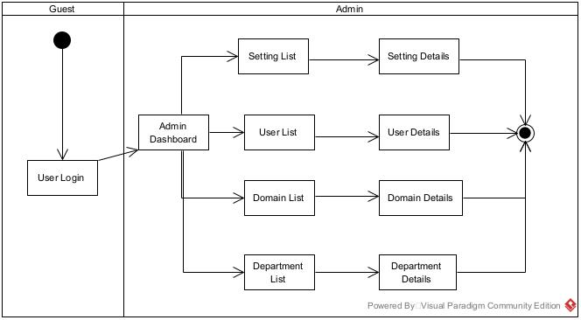

#### 2.4.3 Project Manager Features Workflow

## 

#### 

#### 

#### 

#### 

#### 2.4.4 Allocation Workflow

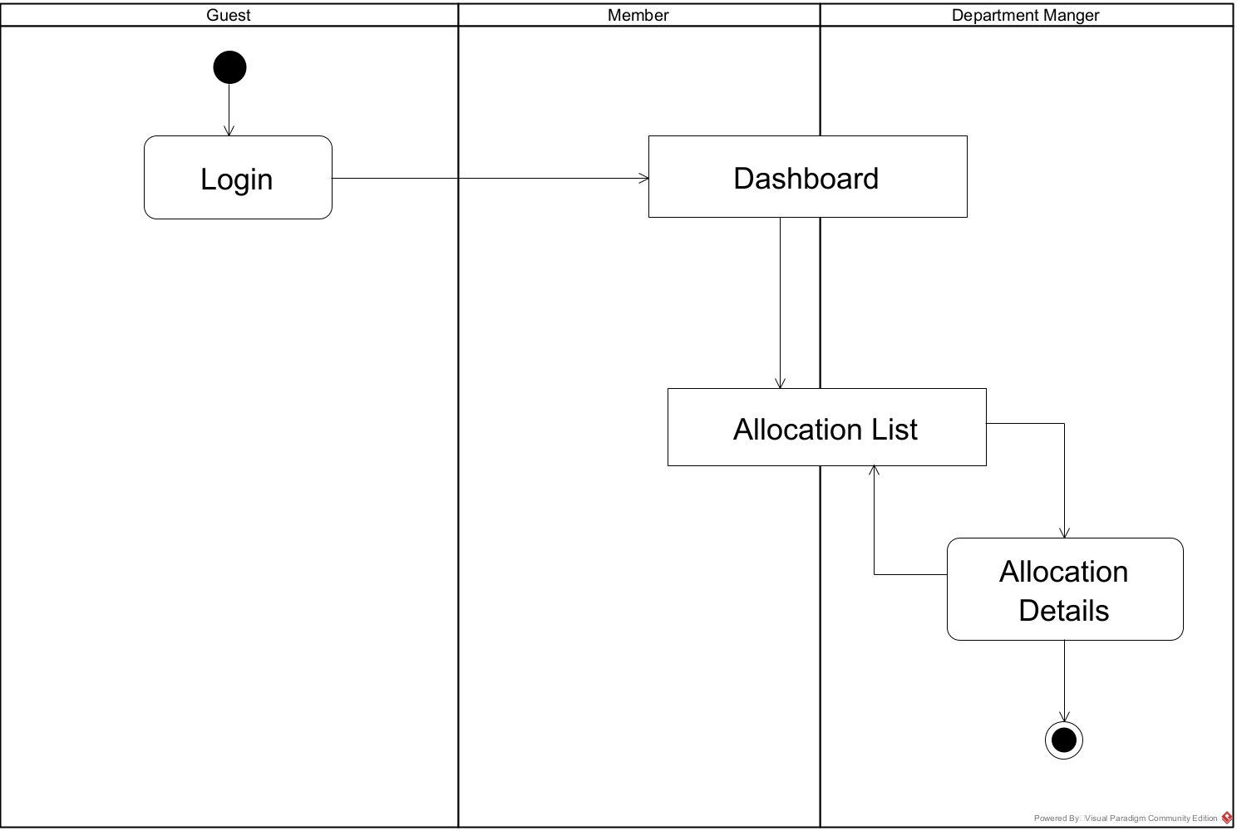

## 

#### 2.4.5 Issue Workflow

## 

#### 2.4.5 Defect Workflow

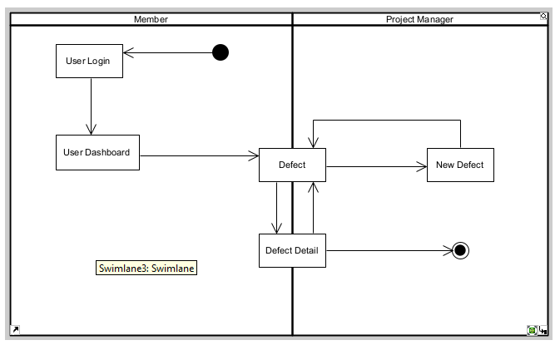

#### 2.4.6 Domain WorkFlow

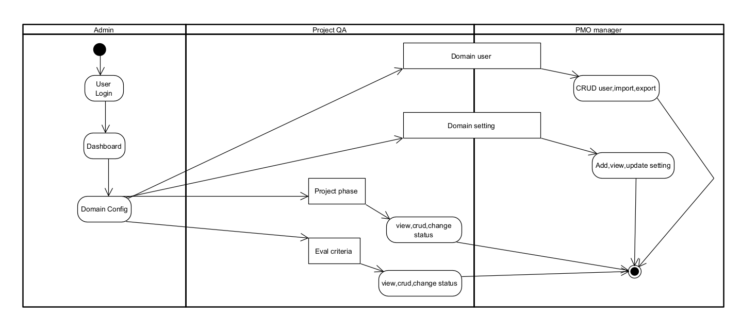

#### 2.4.7 Requirement WorkFlow

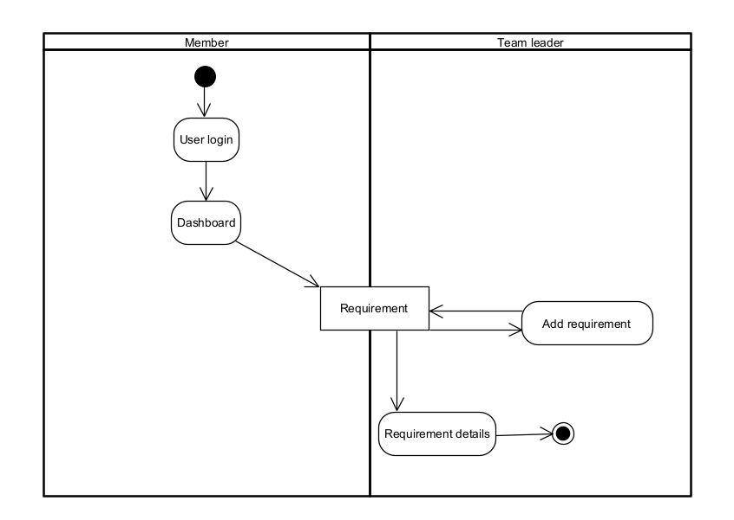

#### 2.4.8 Timesheet WorkFlow

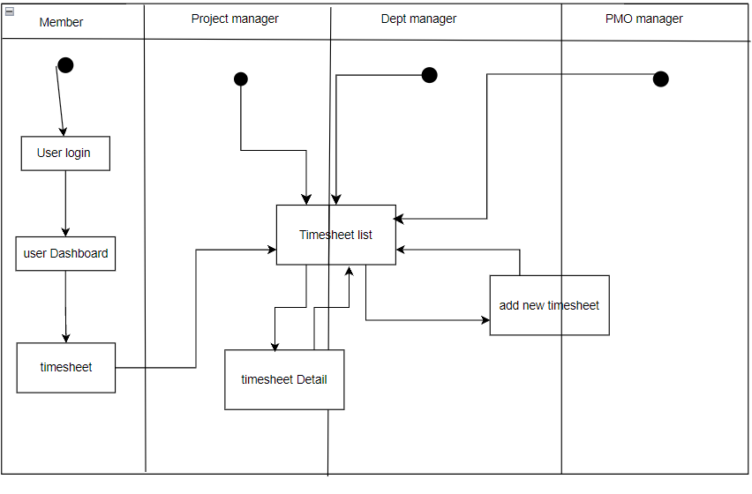

## 

## 

## 

## 

## 

## 3. System Functionalities

### 3.1 Screens Flow

### 

### 3.2 Screen Authorization

| **Screen** | **Member** | **Guest** | **PMO** | **Project manager** | **Project QA** | **Team Leader** | **Dept Manager** | **Admin** |
| --- | --- | --- | --- | --- | --- | --- | --- | --- |
| Dashboard | x |  | x | x | x | x | x | x |
| Query Data | x |  | x | x | x | x | x | x |
| User Profile | x |  | x | x | x | x | x | x |
| Query Data | x |  | x | x | x | x | x | x |
| Update Data | x |  | x | x | x | x | x | x |
| Change Password | x |  | x | x | x | x | x | x |
| Update Data | x |  | x | x | x | x | x | x |
| User list |  |  |  |  |  |  |  | x |
| User detail |  |  |  |  |  |  |  | x |
| Setting List |  |  |  |  |  |  |  | x |
| Setting Details |  |  |  |  |  |  |  | x |
| Domain Config |  |  | x |  | x |  |  | x |
| Domain User |  |  | x |  | x |  |  | x |
| Domain Setting |  |  | x |  | x |  |  | x |
| Domain Criteria |  |  | x |  | x |  |  | x |
| Phase list |  |  | x |  | x |  |  | x |
| Phase detail |  |  | x |  | x |  |  | x |
| Milestone List | x |  |  | x |  |  |  | x |
| Milestone Details | x |  |  | x |  |  |  | x |
| Project phase criteria |  |  | x |  | x |  |  | x |
| Requirement | x |  |  | x |  | x |  | x |
| Issue List | x |  |  | x |  |  |  | x |
| New Issue |  |  |  | x |  |  |  | x |
| Issue Details | x |  |  | x |  |  |  | x |
| Defect list | x |  |  | x |  |  |  | x |
| New defect | x |  |  | x |  |  |  | x |
| Defect detail | x |  |  | x |  |  |  | x |
| Allocation List | x |  | x | x | x | x | x | x |
| Allocation details | x |  | x | x | x | x | x | x |
| Project Criteria | x |  | x | x | x | x | x | x |
| Project Member | x |  | x | x | x | x | x | x |
| Project Team | x |  | x | x | x | x | x | x |
| Team Details |  |  | x | x | x | x | x | x |
|  |  |  |  |  |  |  |  |  |

### 3.3 Non-UI Functions

| **#** | **Feature** | **System Function** | **Description** |
| --- | --- | --- | --- |

# 

# II. Functional Requirements

## 1. User Features

### 1.1 Login

Users can choose to log in with a registered Email account or register with a personal Email. In addition, users can also choose to register a new account. If you forget your password, you can also retrieve your password.

**Login:**

Allows users to enter Email, Password and log in.

**Sign in with Gmail:**

Allows users to log in with a personal Email.

**Forgot password:**

Allows users to retrieve passwords when they lose or forget them

**Register:**

Users sign up for a new account when they don't have an account yet is where the user enters the OTP code and confirms the owner's email.

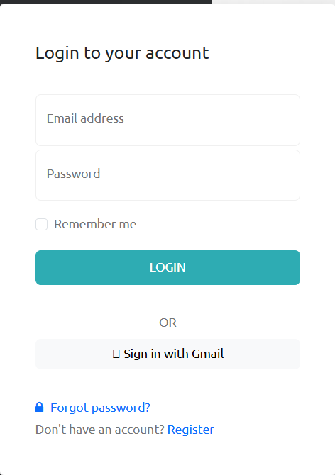

### 

### 

### 

### 

### 1.2 Forgot password

The user will enter the email that needs to retrieve the password.

Click Reset password will take the user to the page to enter the OTP code to verify the Email address.

Chosen Login will take the customer to the login screen.

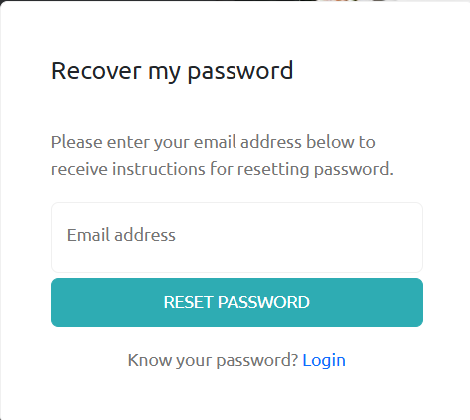

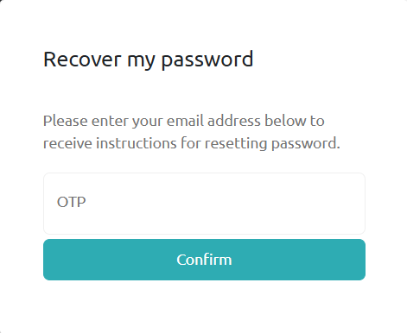

After confirming the main email, the user will be redirected to the password change screen

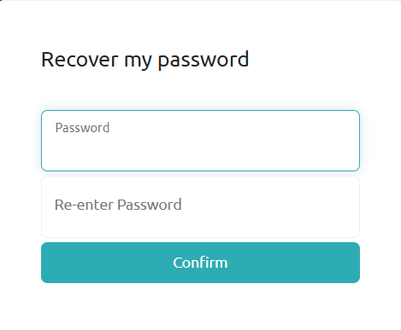

After successfully changing, the system will switch to the log screen. User logs in as Login screen

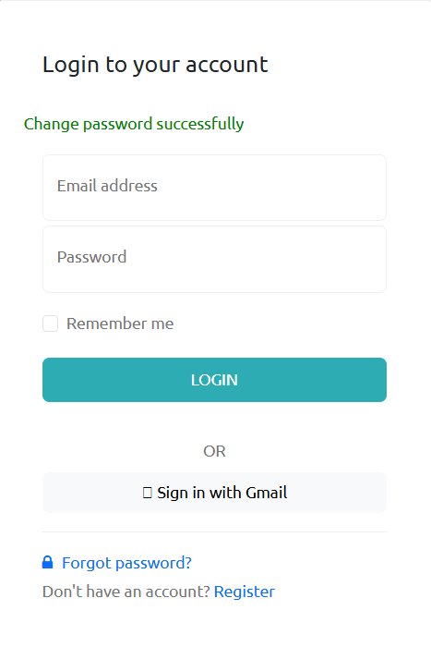

### 

### 

### 

### 1.3 Register

The registration screen allows users to register an account, enter personal information, and can also log in with an unused Google account.

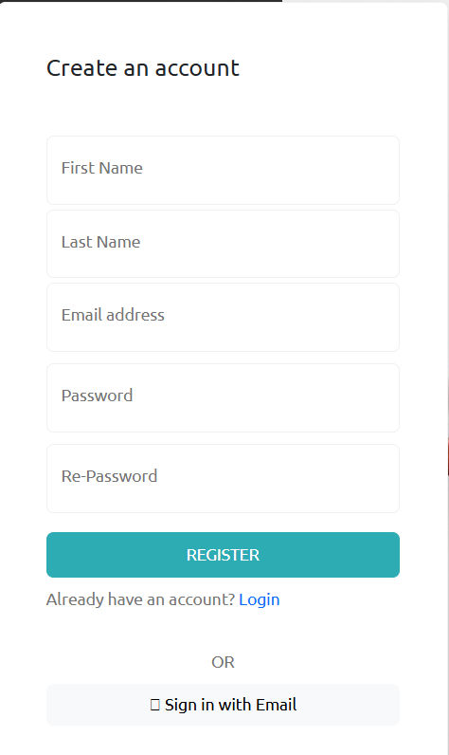

### 1.4 Dashboard

This screen allows users to view their assigned/related projects of the user and some summarization on their works

The dashboard is show to user in one of the below cases:

* He/she just login from the login page.
* He/she click on the Dashboard link on the sidebar
* He/she clicks on the logo on the navigation bar when already logined in.

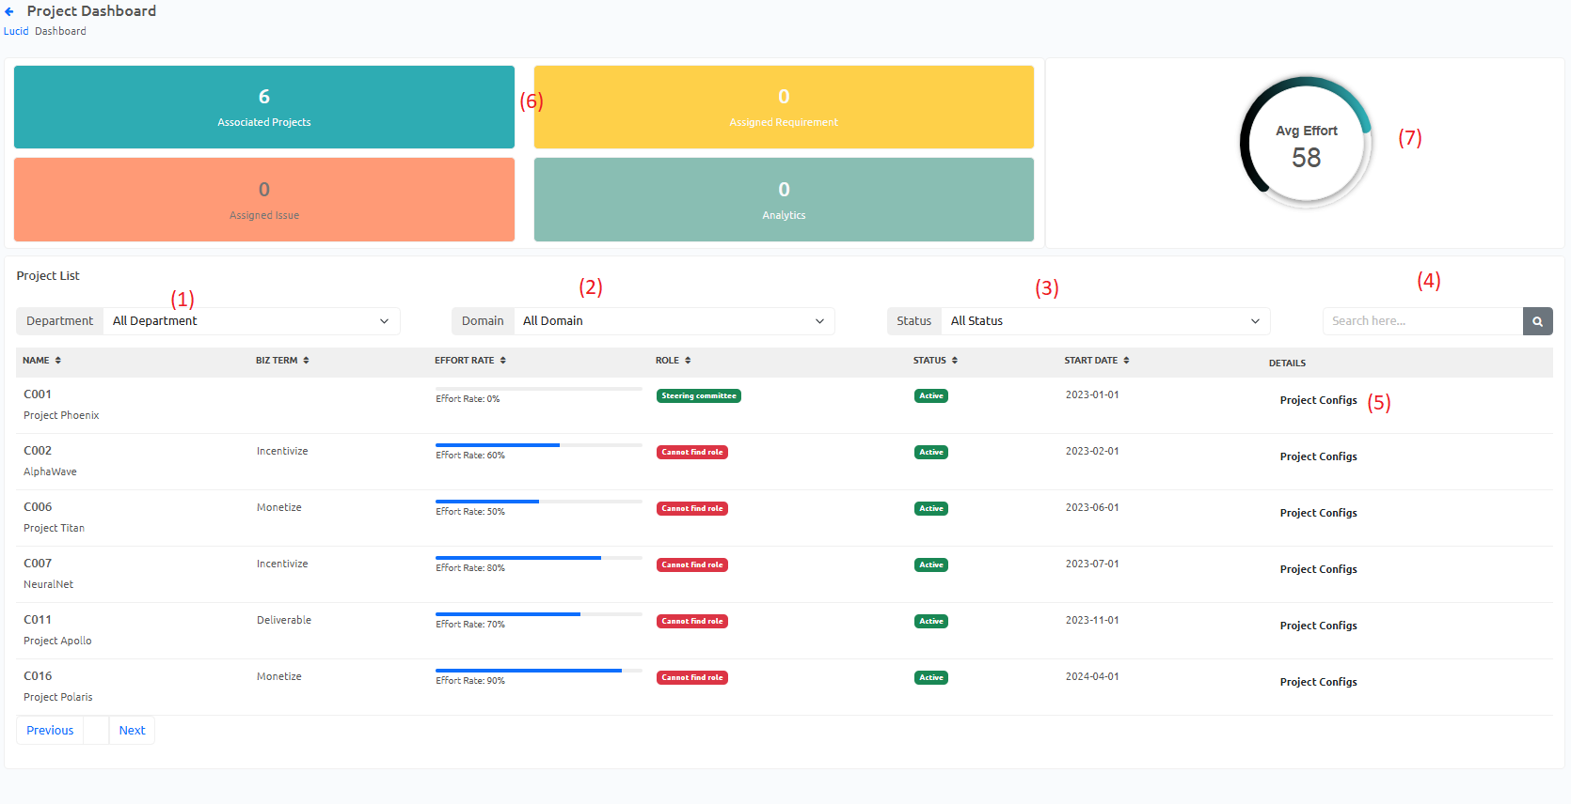

(1) Setting department:

* Initialized with all the active domain filled in
* Allow user to filter the involved project list by a specific domain
* Default value is “All Domain”, allowing user to see involved projects at all domain

(2) Setting domain:

* Initialized with all the active domain filled in
* Allow user to filter the involved project list by a specific domain
* Default value is “All Domain”, allowing user to see involved projects at all domain

(3) Setting status:

* Initialized with all value of status of projects filled in
* Allow user to filter the involved project list by a specific status
* Default value is “All Status”, allowing user to see involved projects at all status

(4) Search bar:

* Search by a part of the name of the project.

(5) View project config:

* Allow users to view specific involved project details.

(6) Summarize information about user activities.

(7) Average effort rate of use.

### 1.5 User Profile + Password change

This screen allows user to view their account information and update if needed

The user profile screen is show to user in one of below cases:

* He/she click the User Profile link in the sidebar
* He/she click on the My Profile in dropdown menu on the user account section on top of sidebar

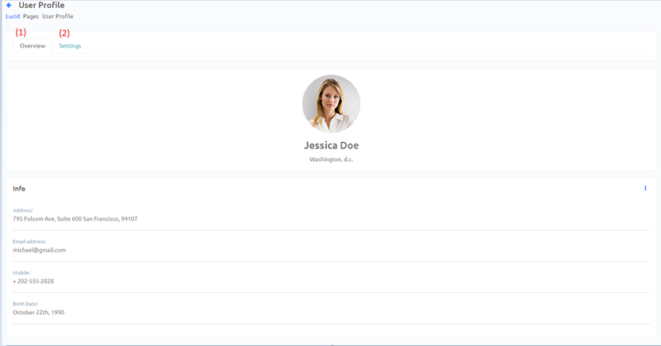

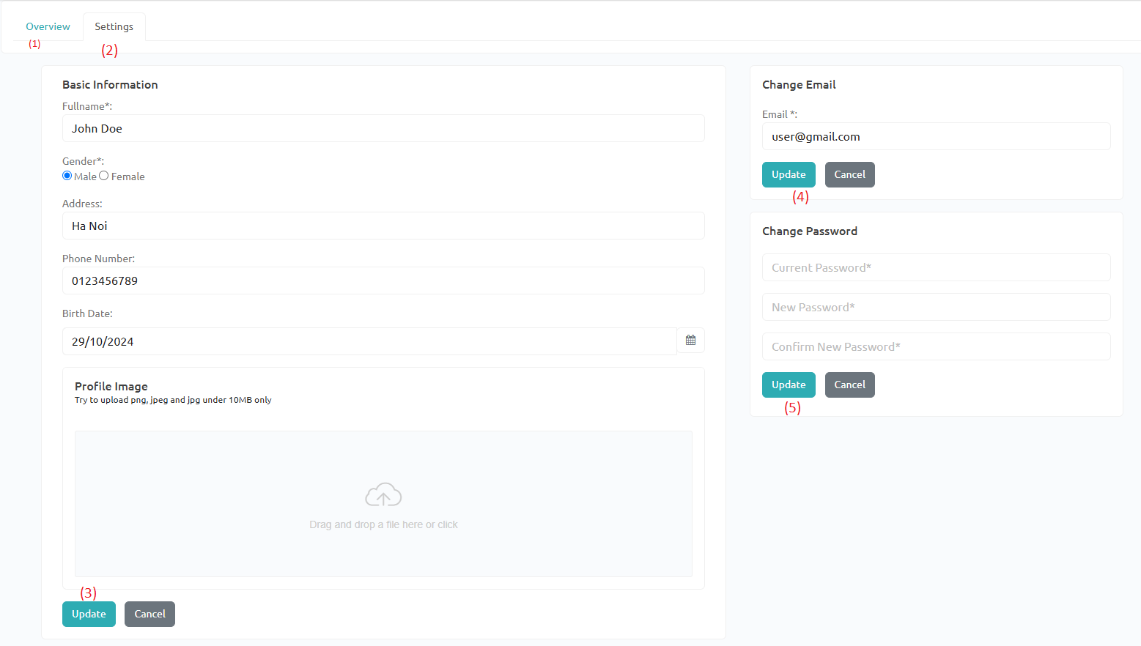

1. Overview section:

* This section is for displaying an overview of basic information of the user.

1. Setting section:

* This section is for update all user’s information and changing user’s password

1. Update basic information:

* Allow user to see and update their basic information
* By default, all fields will be filled with their information
* When click update button, a modal will be shown to get confirmation
* When click cancel button, all field will be reset

1. Change Email:

- Allow the user to change the email of the account.

- Users have to verify the new account.

- When click update button, a modal will be shown to get confirmation

* When clicking the cancel button, all fields will be reset.

1. Change password:

* Allow user to fill in the current password and new password to change account’ password
* By default, all fields will be empty
* When click update button a modal will be shown to get confirmation
* When click cancel button, all field will be reset

## 2. System Administration

### 2.1 Setting List

The **Setting List** page is used by the administrator to view, search, filter, and manage system settings. The administrator can see a list of current system settings and take actions such as editing or deactivating them.

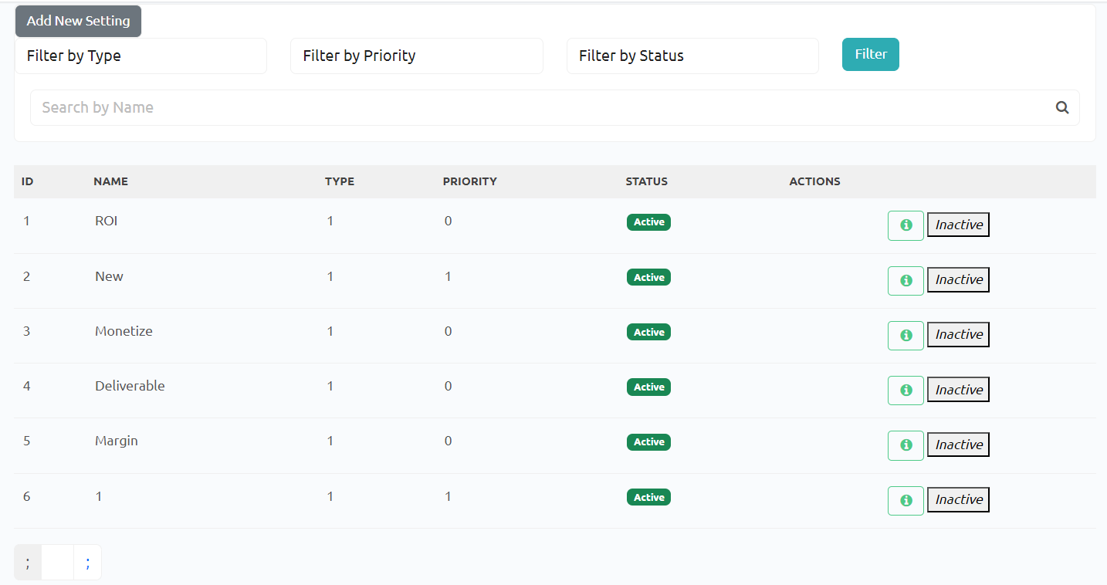

* **Display All Settings**:

The system shall display all current settings in a tabular format, including columns: ID, Name, Type, Priority, Status, and Action.

* **Search Functionality**:

The system shall allow users to search settings using keywords via a search bar.

* **Filter by Type**:

The system shall allow users to filter the list by setting type (e.g., User Role, Business Term).

Default: "All Types" to display all setting types.

* **Filter by Status**:

The system shall allow filtering by the current status of the settings (Active or Inactive).

Default: "All Statuses" to display both active and inactive settings.

* **Activate/Deactivate Settings**:

The system shall provide options to activate or deactivate settings, based on their current status.

Display "Deactivate" for active settings and "Activate" for inactive ones.

The system shall require a confirmation message before finalizing the status change.

* **Edit Settings**:

The system shall provide an **Edit** button for each setting to allow administrators to modify details.

* **Add New Setting**:

The system shall provide a link/button labeled **New Setting** to add a new configuration.

* **Pagination**:

The system shall paginate settings if the list exceeds 10 entries per page, allowing navigation between pages.

### 2.2 Setting Details

The **Setting Details** page is shown after the user clicks the **New Setting** link or the **Edit** link in the **Setting List** page. It is used by the administrator to add a new setting or view/edit an existing setting's details

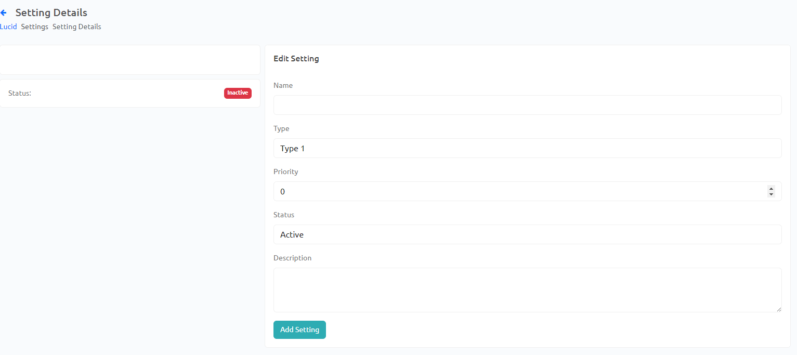

* **Display Setting Details**:
* The system shall display the following fields for editing or adding settings:
  + **Name**: Input field for the setting name.
  + **Type**: Dropdown to select the setting type (e.g., User Role).
  + **Value**: Input field for the setting value.
  + **Priority**: Input field to set priority level.
  + **Status**: Radio buttons to choose Active or Inactive status.
  + **Description**: Text field for an optional description.
* **Add/Edit Functionality**:

The system shall allow administrators to add new settings or modify existing ones.

* **Submit and Save**:

The system shall provide a **Submit** button to save new or modified settings.

* **Validation**:

The system shall validate that required fields (e.g., Name, Type, Value) are correctly filled before submission.

* **Confirmation**:

The system shall display a confirmation message after the setting has been successfully added or updated.

### 2.3 User List + User Details

Allow users to manage (search/filter/view list, add new, view/update, activate /deactivate) user accounts.

* **Display All Settings**:

The system shall display all current settings in a tabular format, including columns: ID, Email, Fullname, mobile, password, note, department,role,status,image.

* **Filter by Type**:

The system shall allow users to filter the list by setting type (e.g., User Role).

Default: "All Types" to display all setting types.

* **Activate/Deactivate Settings**:

The system shall provide options to activate or deactivate, based on their current status.

Display "Deactivate" for active settings and "Activate" for inactive ones.

The system shall require a confirmation message before finalizing the status change.

* **Edit Settings**:

The system shall provide an **Edit** button for each setting to allow administrators to modify details.

* **Add New Setting**:

The system shall provide a link/button labeled **New Setting** to add a new configuration.

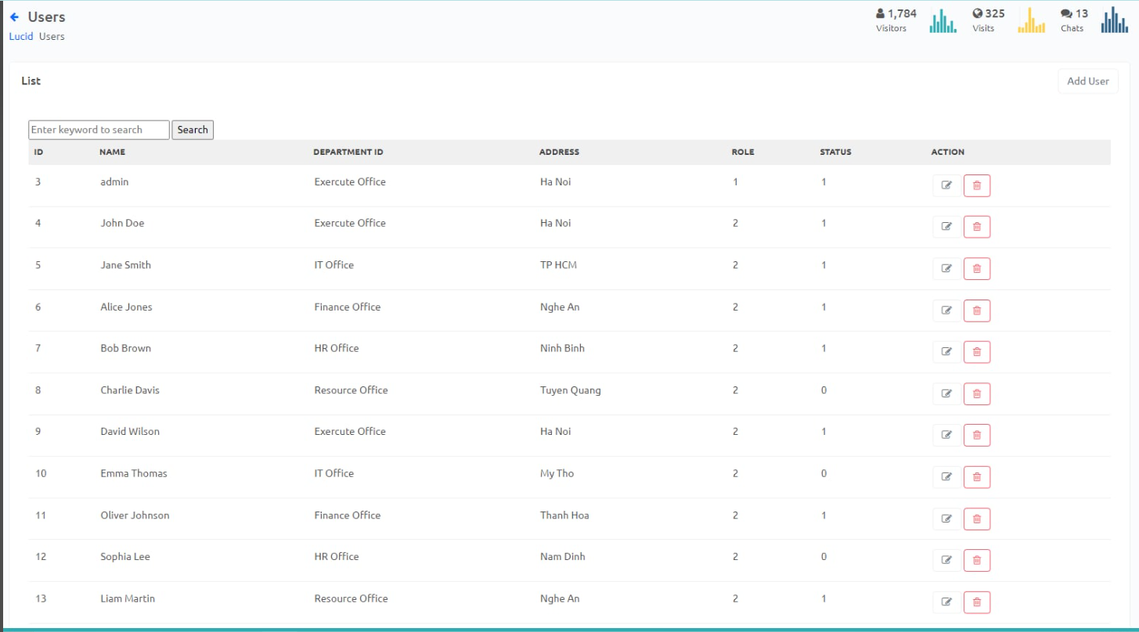

User detail

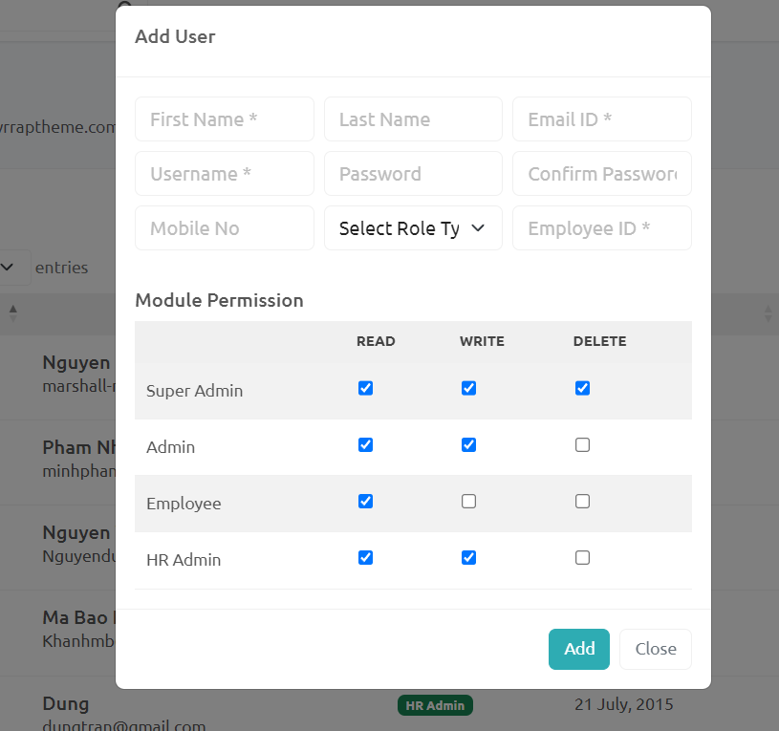

* **Display User Details**:
* The system shall display the following fields for editing settings
* Submit and save

### 2.4 GroupList + Group Details

**Domain:**

Allow user to manage (search/filter/view list, add new, view/update, activate /deactivate) project domains

* He/she just login from the login page.
* He/she click on the Group Management link on the sidebar
* He/she clicks on the Domain Management when already logged in.

1. Add new: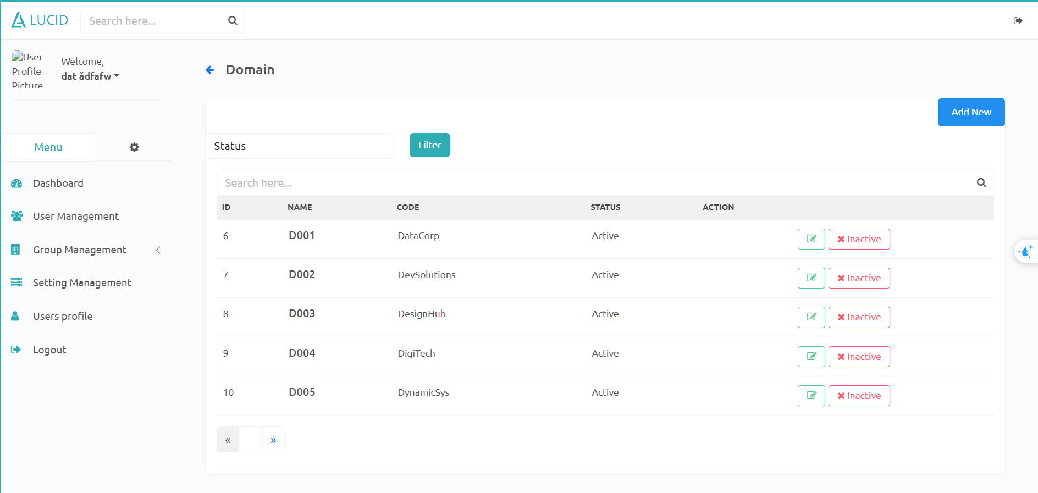
   1. Allow user to add new domain
2. filter:
   1. allow user to filter by status
3. Detail:
   1. allow user to view detail domain
   2. Allow users to edit the domain
4. Search bar:
   1. Search by a part of the name of the project.

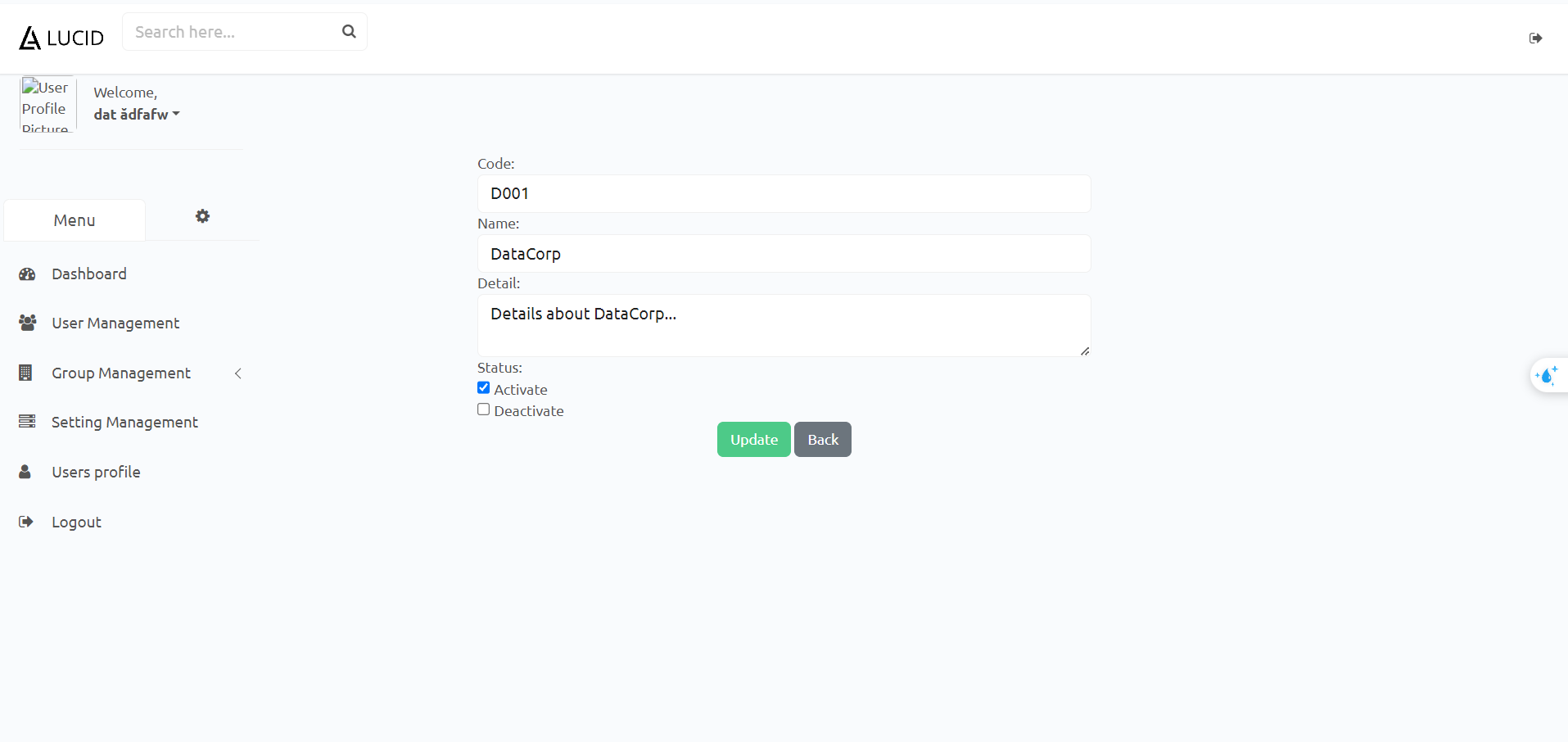

**Department:**

Allow user to manage (search/filter/view list, add new, view/update, activate /deactivate) company departments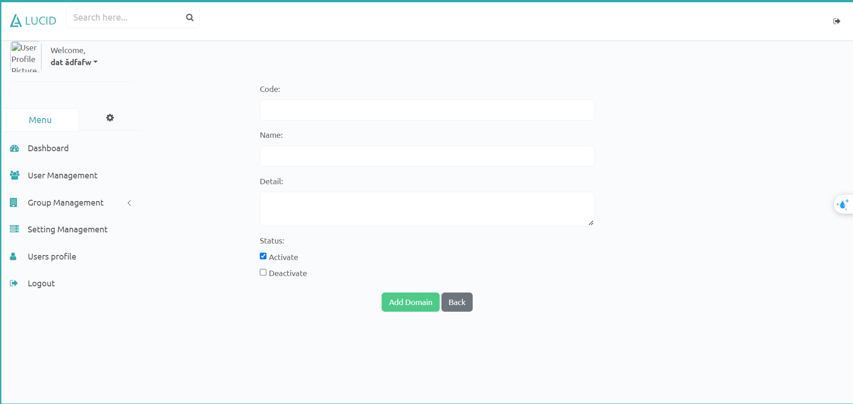

* He/she just login from the login page.
* He/she clicks on the Group Management link on the sidebar
* He/she clicks on the Department Management when already login.

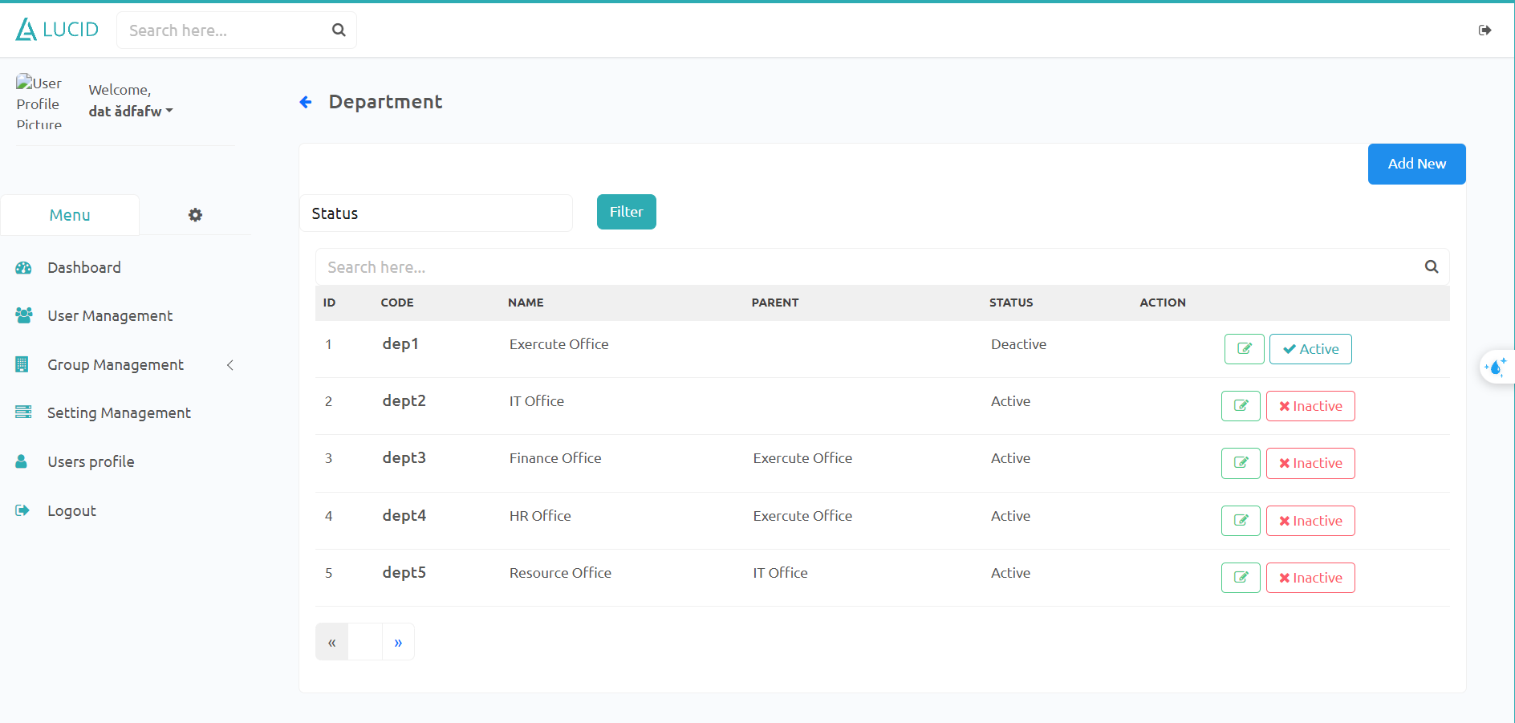

1. Add new:
   1. Allow user to add new department
2. filter:
   1. allow user to filter by status
3. Search bar:
   1. Search by a part of the name of the project.
4. Detail:
   1. allow user to view detail department
   2. Allow users to edit the department

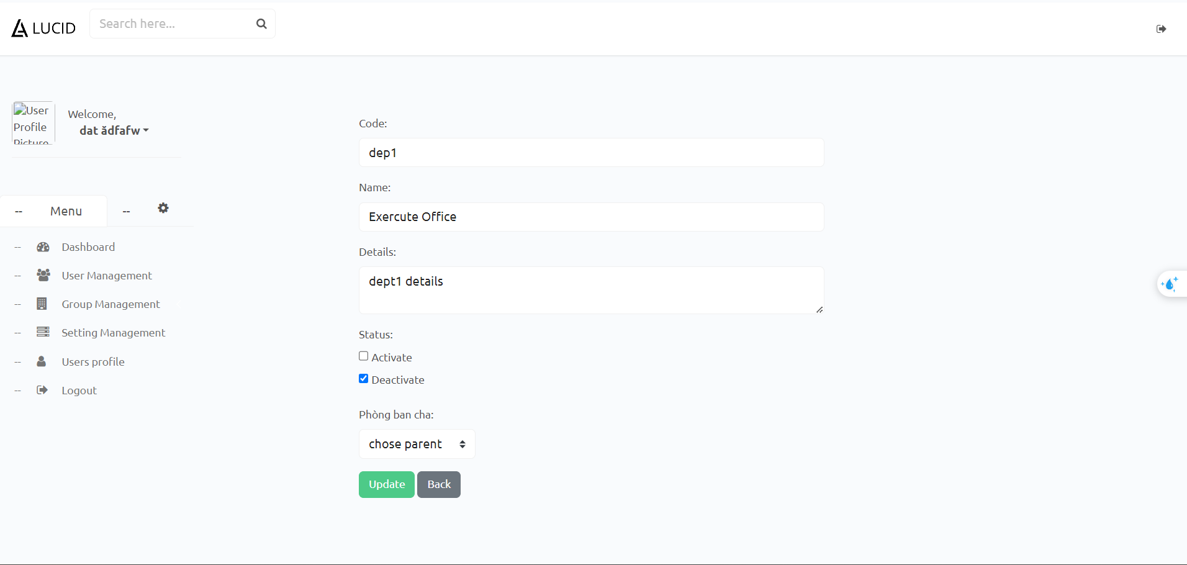

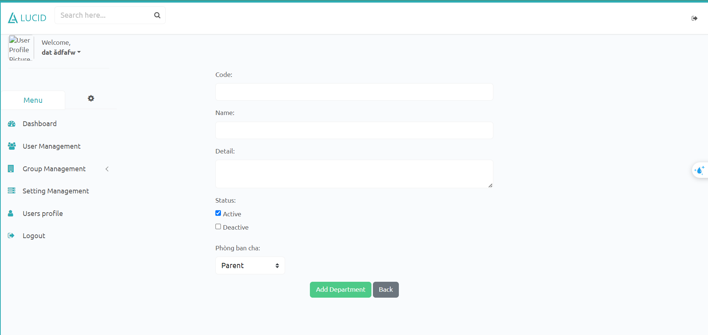

## 

## 

## 

## 3. Project Manager Features

### 3.1. Project Evaluation

This screen will allow project managers to view their assigned project’s list of evaluation criteria, activate/deactivate, delete, update and add new criteria.

User can access to this screen by the following cases:

* He/she click the Evaluation Criteria tab on the Project Config page

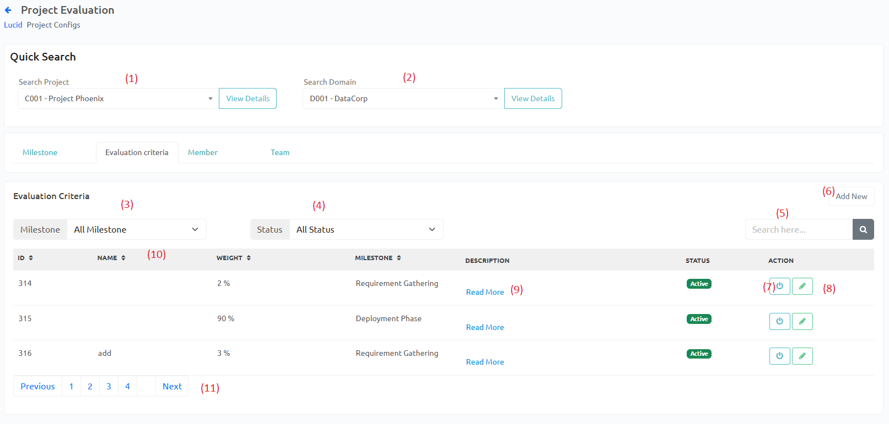

1. Quick search project to go to others project’ config page.
2. Quick search domain to go to domain’s config page.
3. Filter evaluation criteria by milestone.
4. Filter evaluation criteria by status.
5. Search evaluation criteria by part of name.
6. Open Add new modal.
7. Activate/Deactivate criteria.
8. Open modal to update criteria.
9. Read more/less criteria descriptions.
10. Click on table headers to sort.
11. Click Previous/Next to change the page.

|  |  |
| --- | --- |

### 3.2. Project Milestone

This screen will allow project managers to view their assigned project’s list of milestones, activate/deactivate, update milestones.

User can access to this screen by the following cases:

* He/she click Project Detail on the Project List on the Project Dashboard page

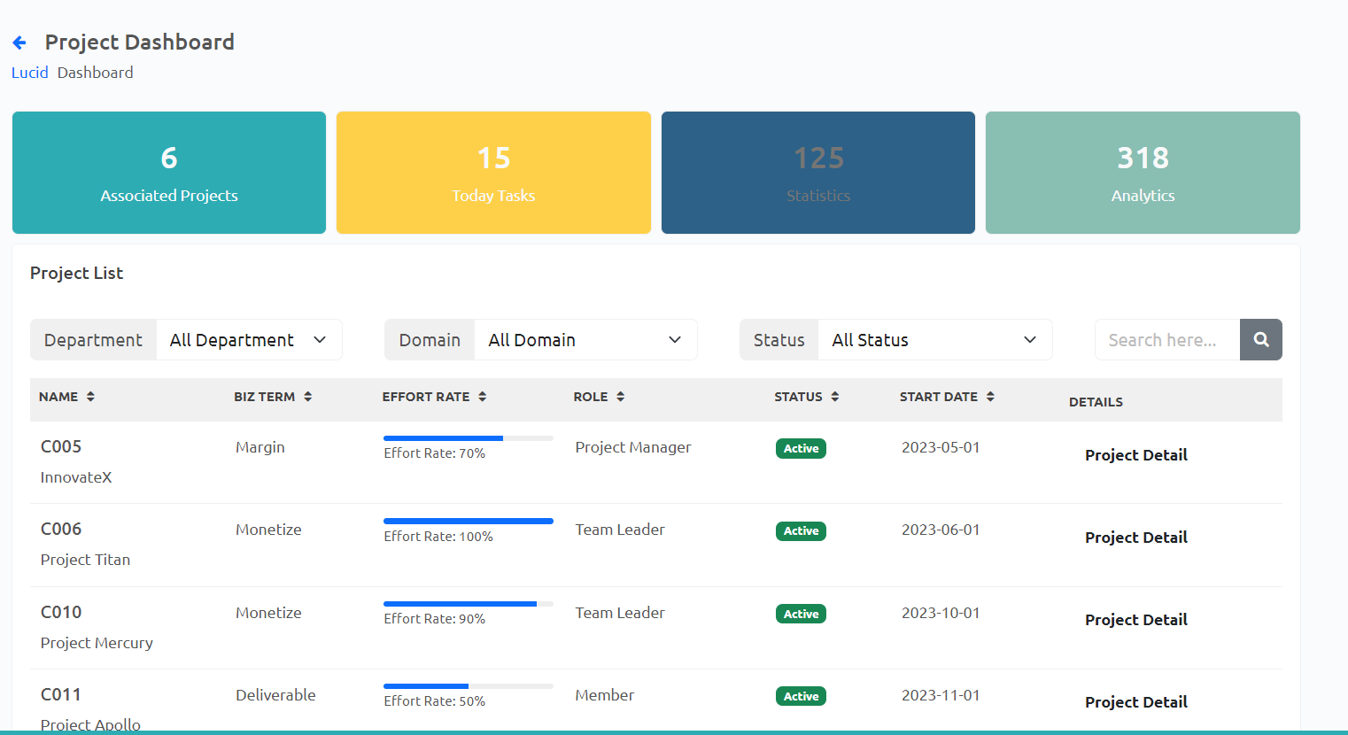

* He/she view the Milestone tab on the Project Config page

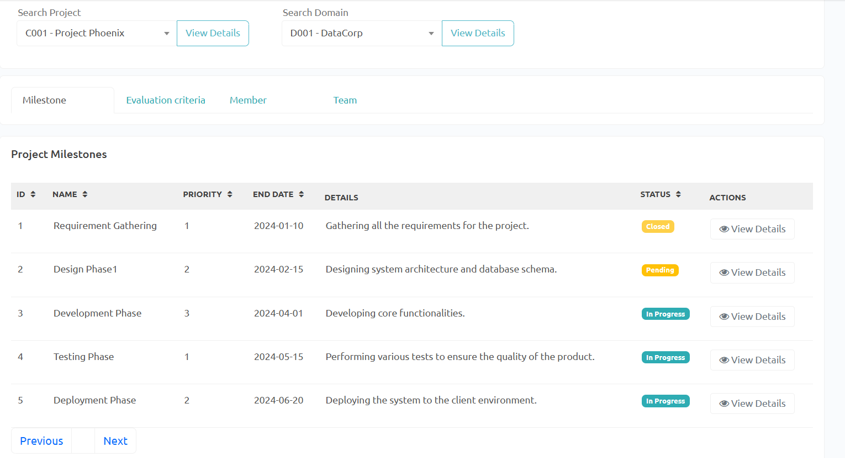

* Quick search project to go to others project’ config page.
* Quick search domain to go to domain’s config page.
* Click on table headers to sort.
* Open modal to update Milestone.
* Click View details to view/update Milestone.

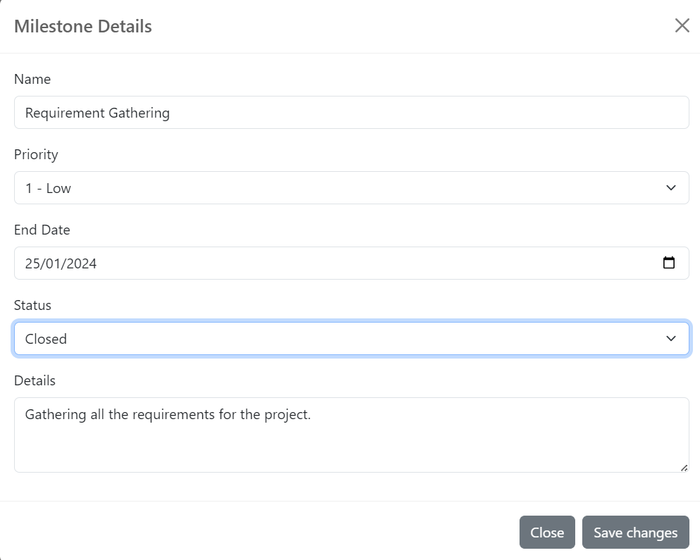

* Click Priority to change.

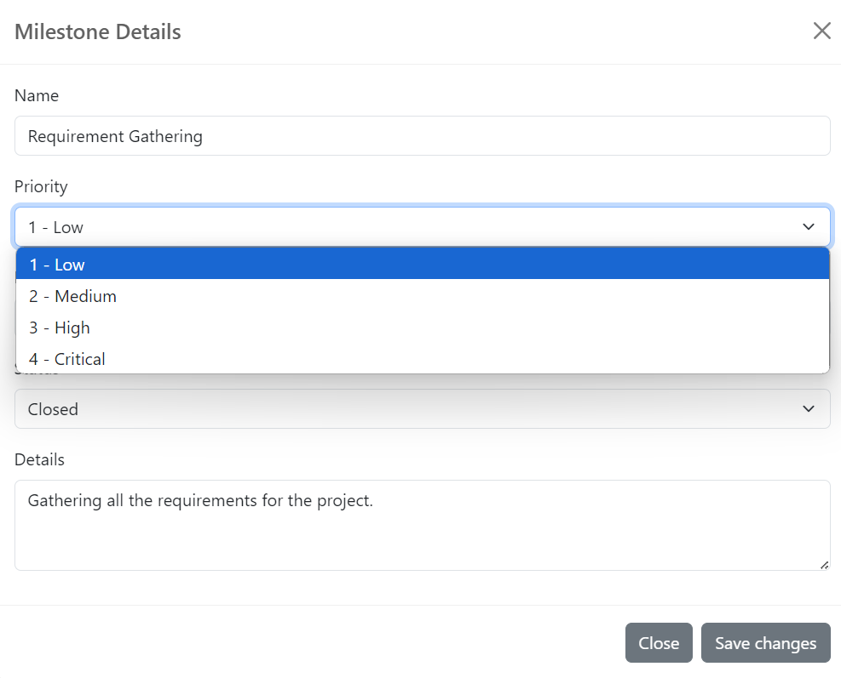

* Click Status to change.

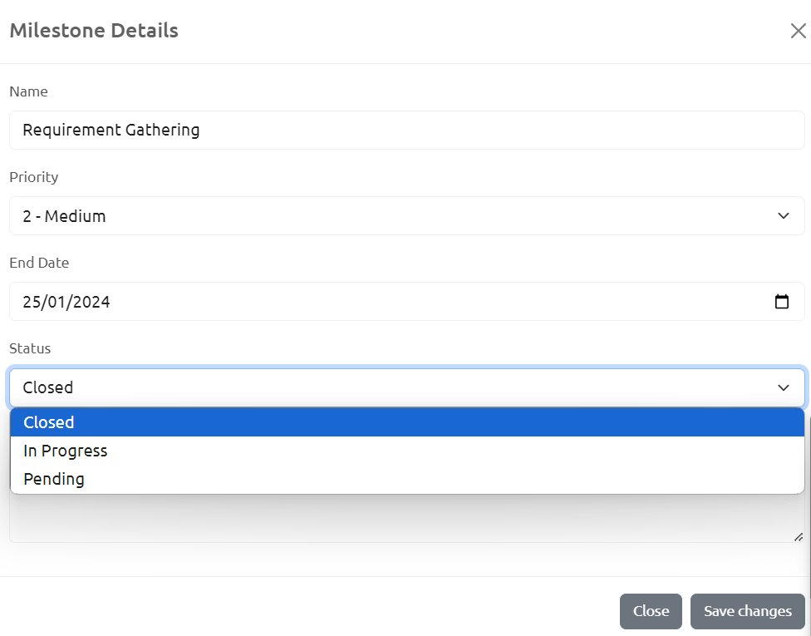

### 3.3. Project Member

This screen will allow project managers to view their assigned project’s list of members, activate/deactivate members or export members list.

User can access to this screen by the following cases:

* He/she click the Member tab on the Project Config page

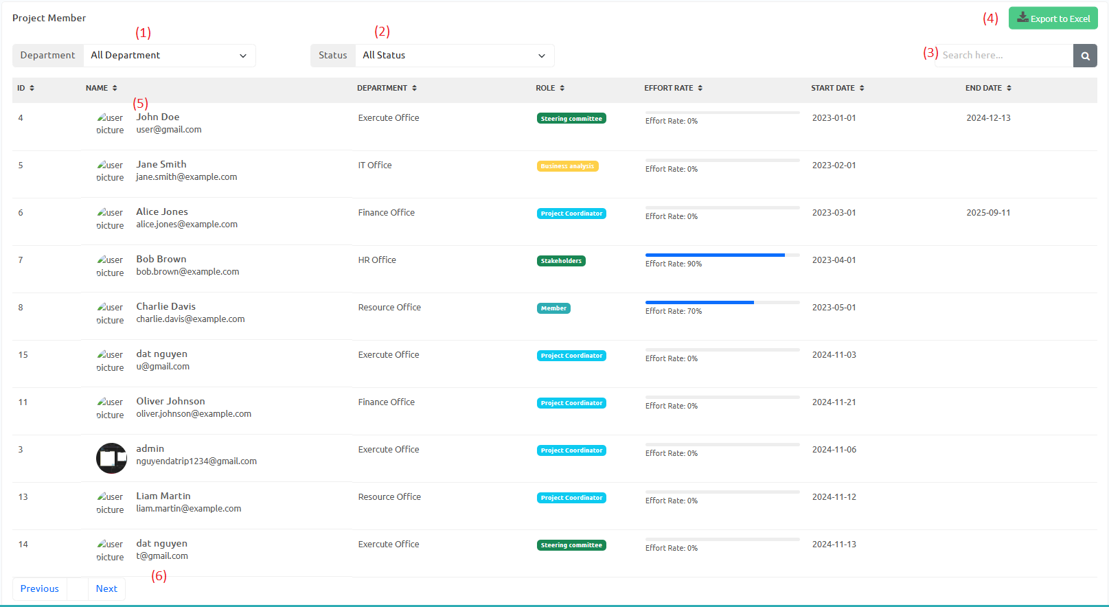

1. Filter project members by department.
2. Filter project members by status.
3. Search project members by part of a name.
4. Export members list to excel.
5. Click on table headers to sort.
6. Click Previous/Next or page number to change the page.

### 3.4. Project Team List + Details

This screen allows users to view the list of teams in the project and structure of those teams. Users can also change the structure of teams in the Team Details screen.

User can access to this screen by the following cases:

* He/she click the Team tab on the Project Config page

Team list screen:

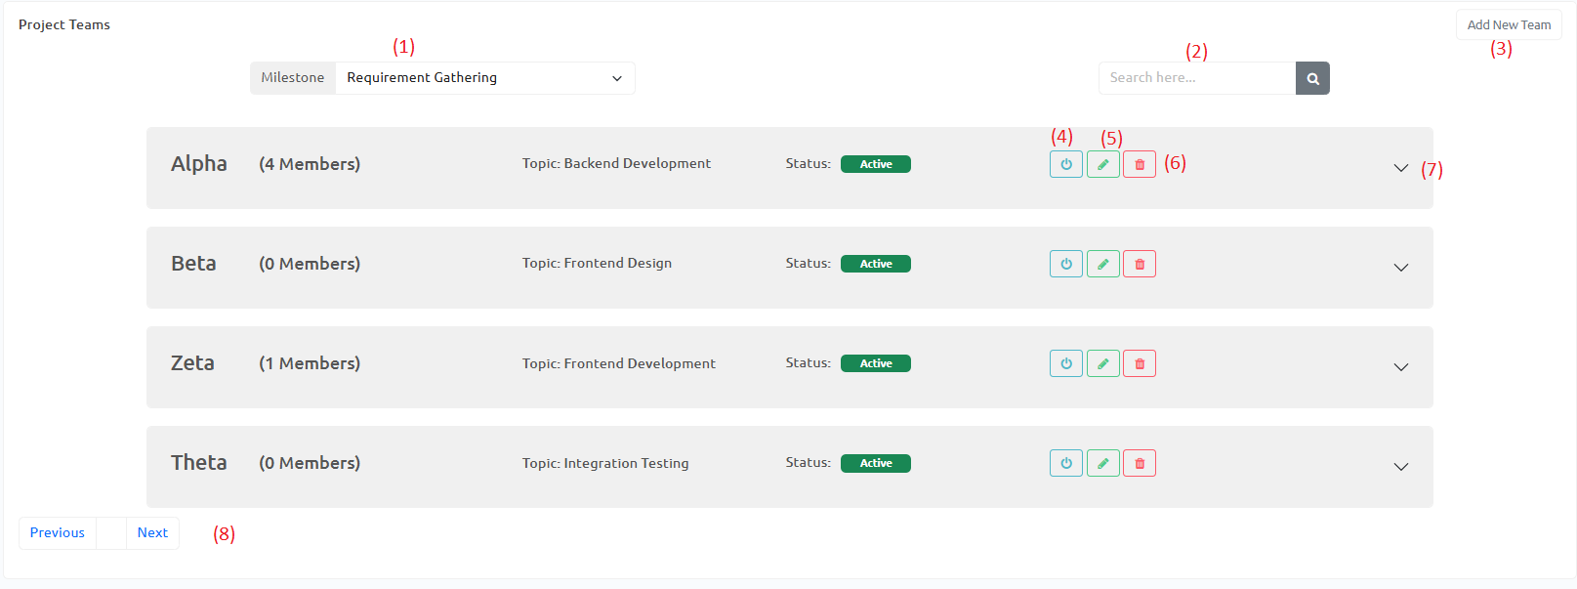

1. Filter project teams by milestone.
2. Search project teams by name.
3. Open add new team modal.
4. Activate/Deactivate team.
5. Open team update modal.
6. Delete team.
7. Open team details.
8. Click Previous/Next or page number to change the page.

|  |  |
| --- | --- |

Team details screen:

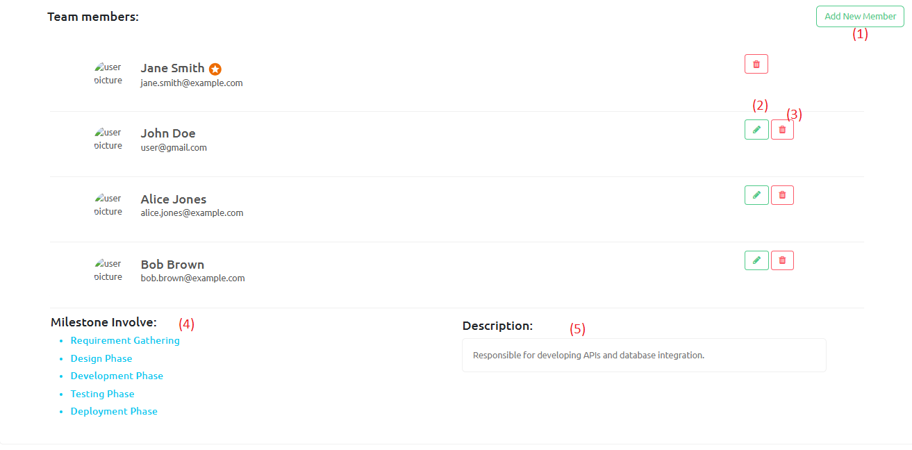

1. Open add new member modal.
2. Promote Member to Team Leader.
3. Delete member from team.
4. Involved milestones of the team.
5. Team’s descriptions.

| Add new members modal | Make Team Lead and delete notifications |
| --- | --- |
|  |  |
|  |

### 

### 

### 

### 

### 

### 

### 

### 

### 

### 

### 

### 

### 

### 3.5. Project List

This screen will allow project managers to view projects in which they are personally involved.

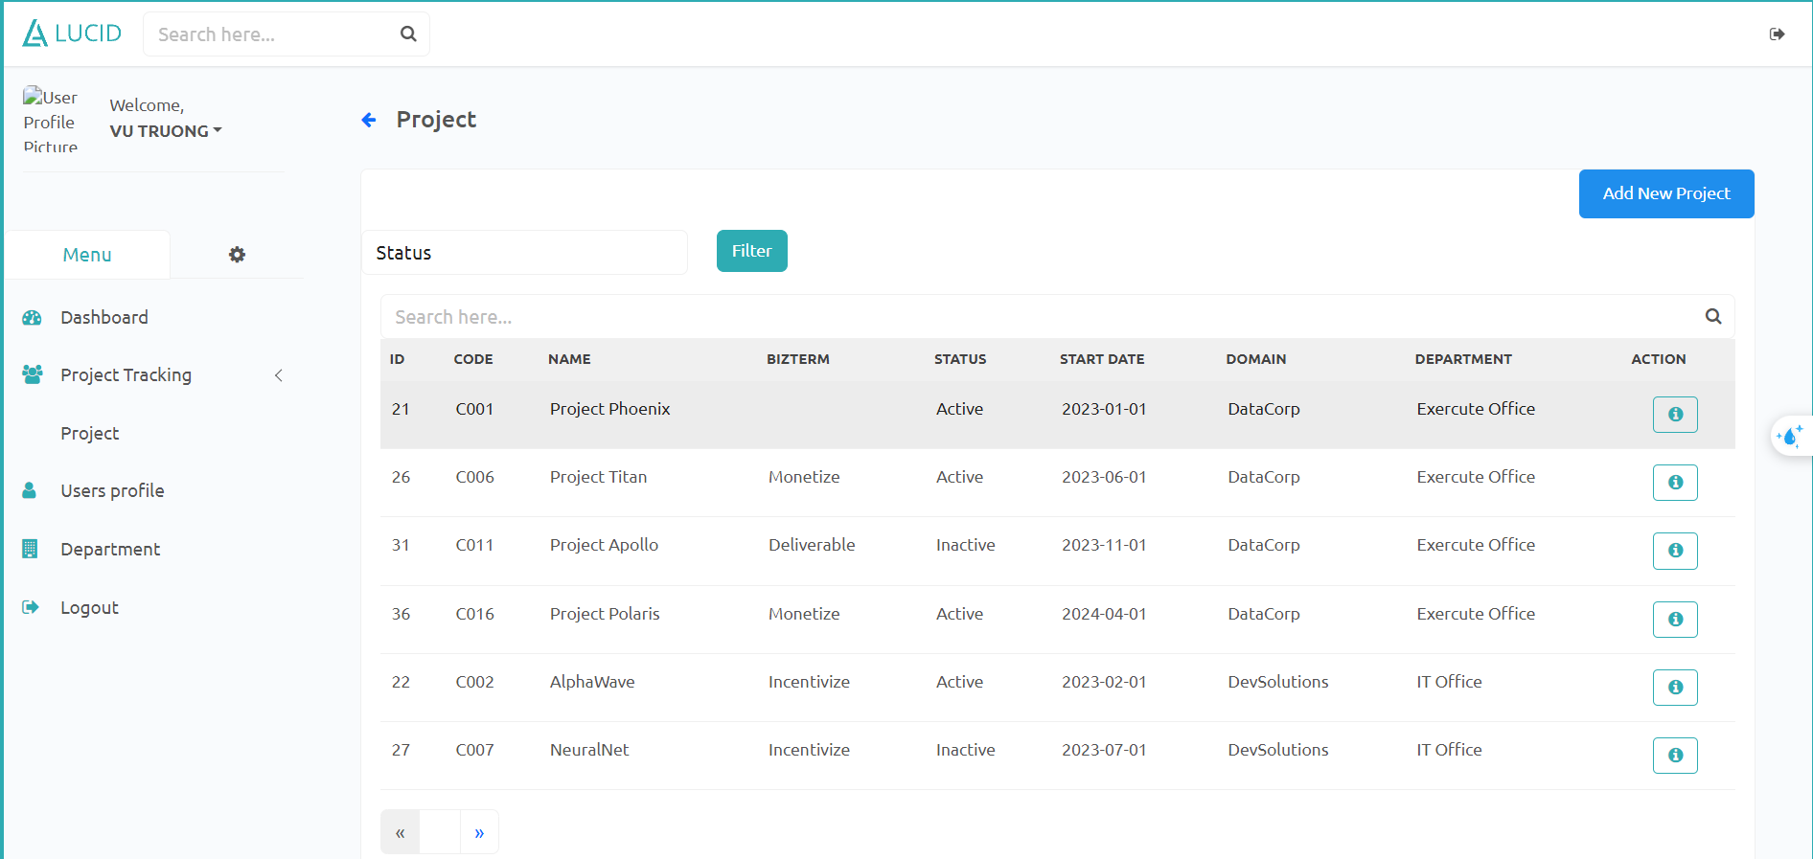

Only project managers can add new projects.By adding a new project, the project milestones are created automatically by cloning relevant project phase details.

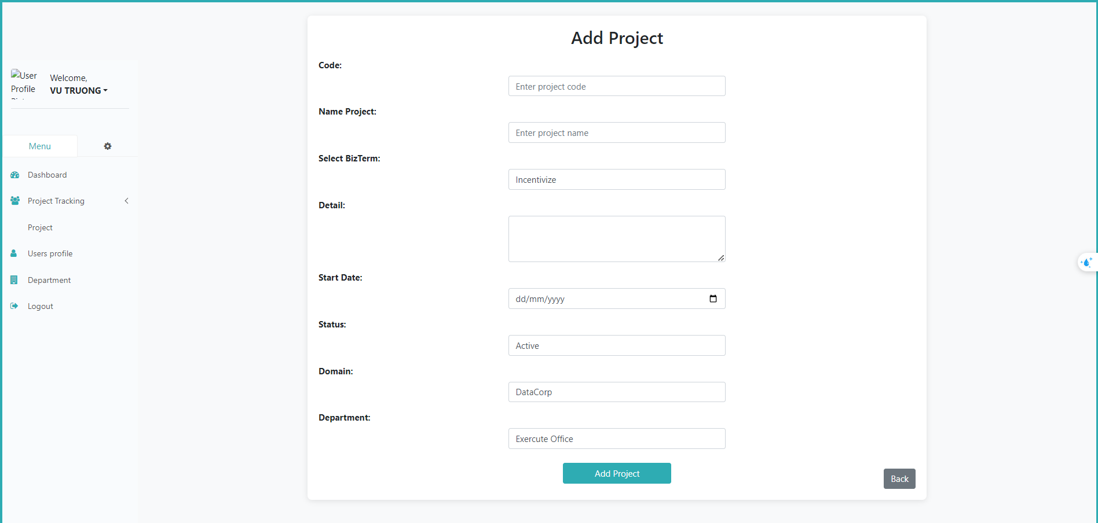

### 3.6. Project Detail

allows project participants to view specific details of each project. only the project manager has the authority to change the status of the project

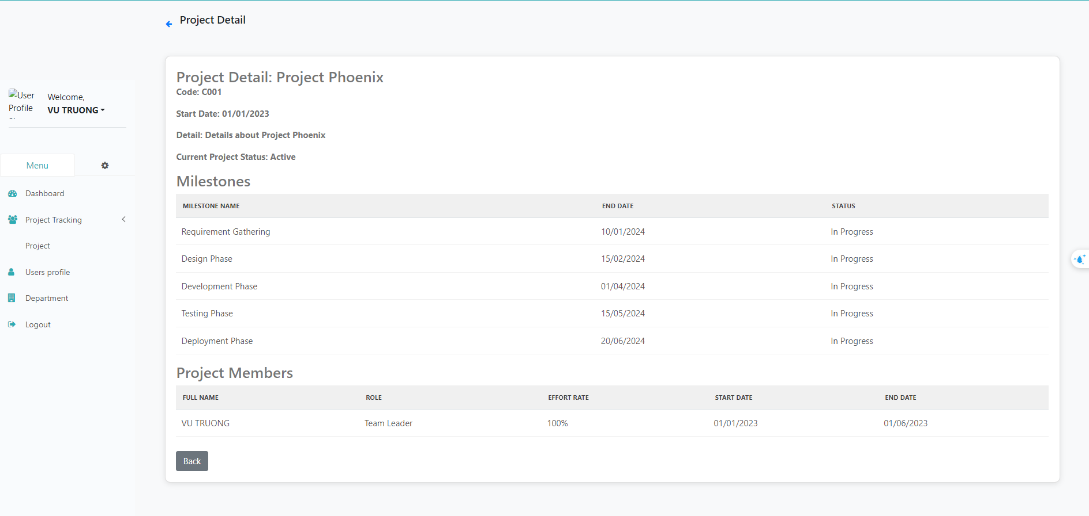

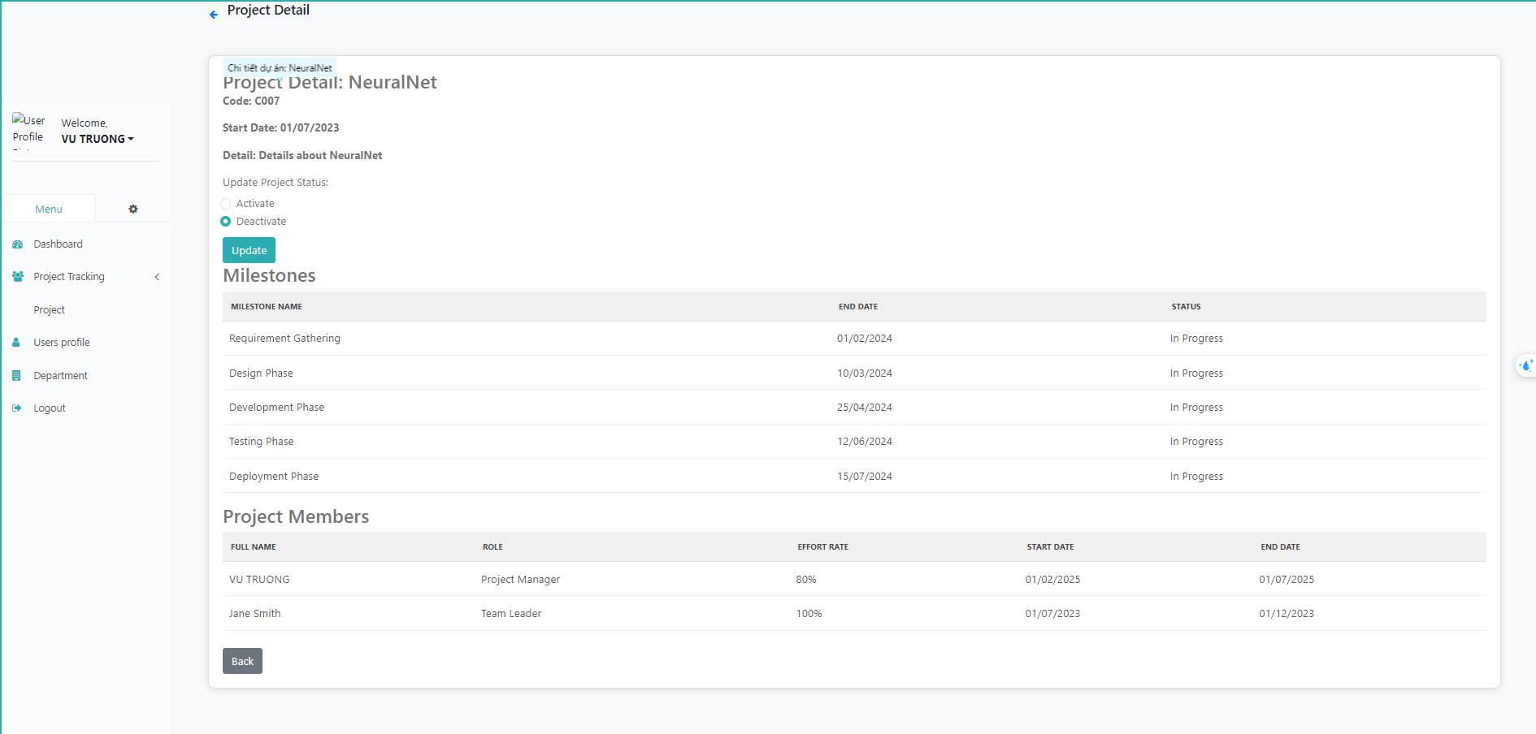

## 

## 4. Project QA Features

### 4.1. Domain User

-Can Add new domain user,import,export ,search and edit domain user

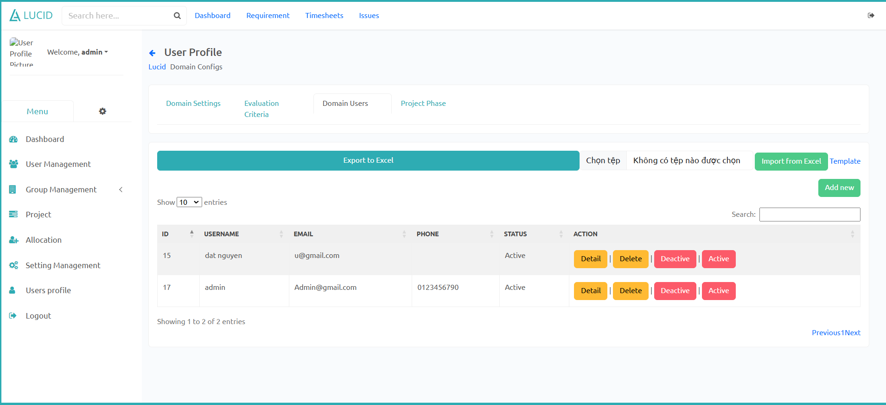

Add domain user

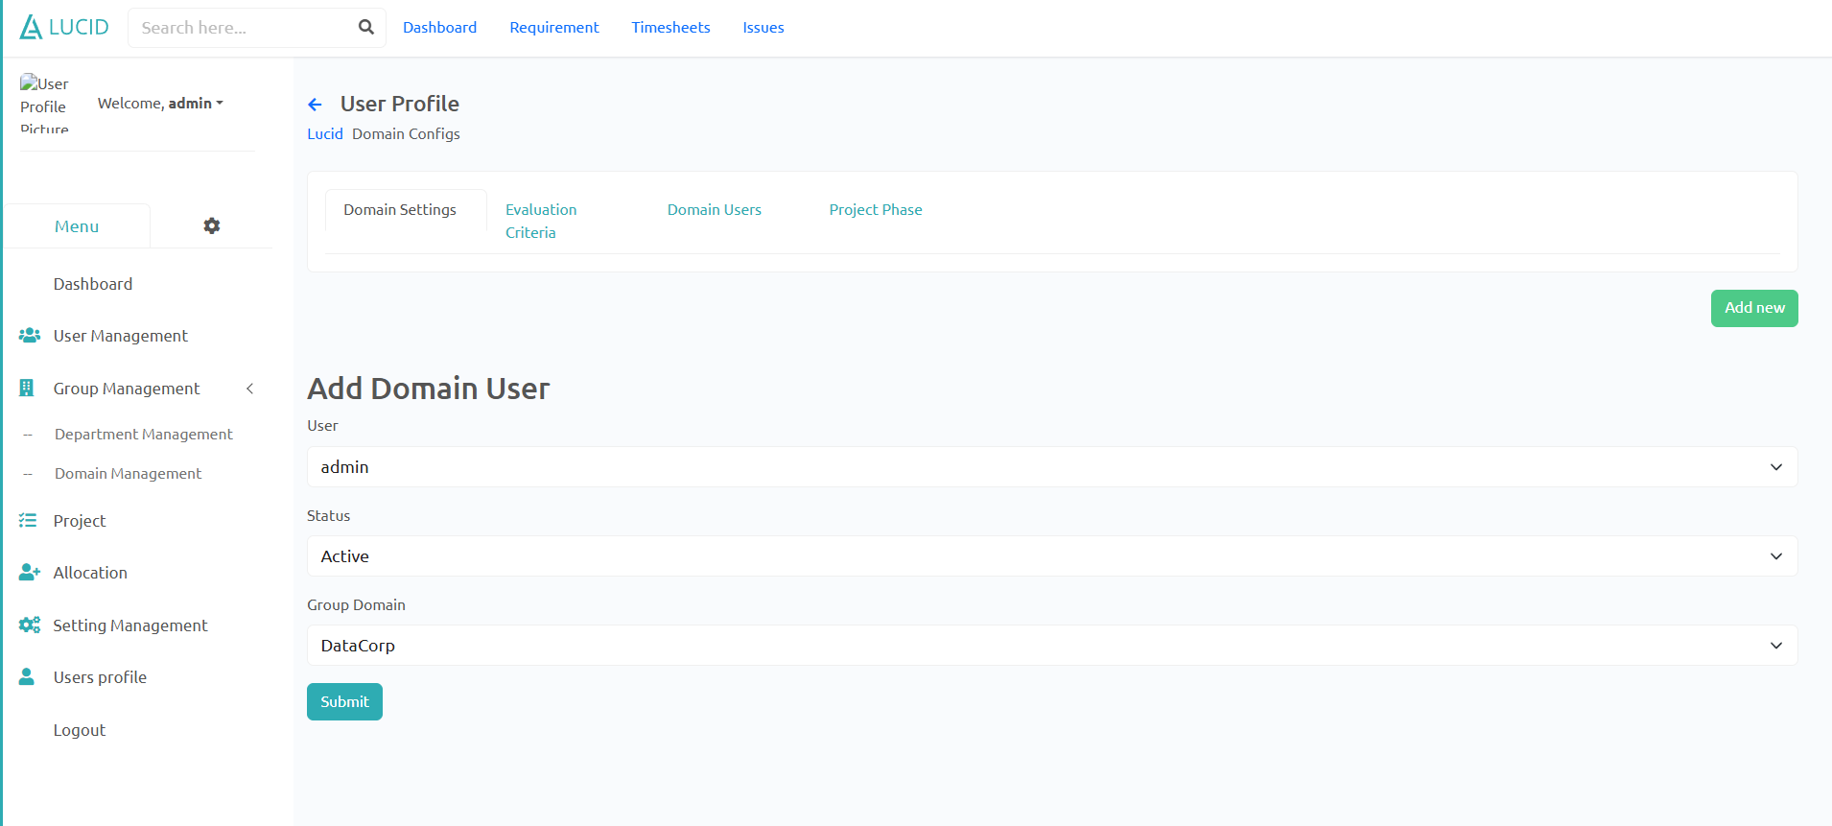

Edit domain eval

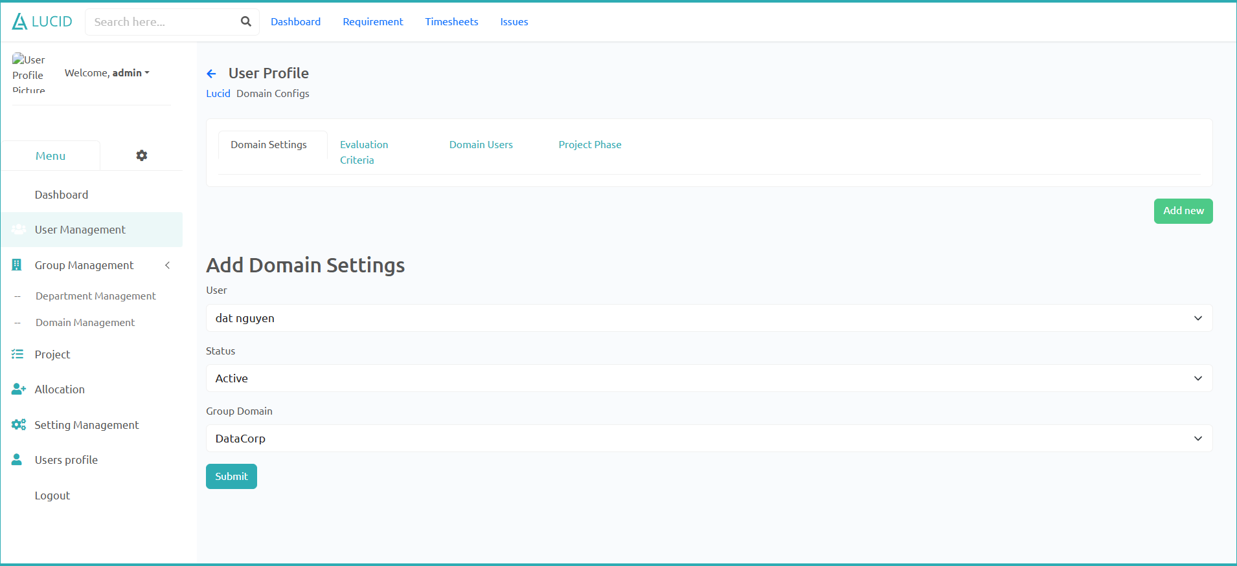

### 4.2. Domain Setting

Can Add new domain setting, filter search, edit and active,inactive status

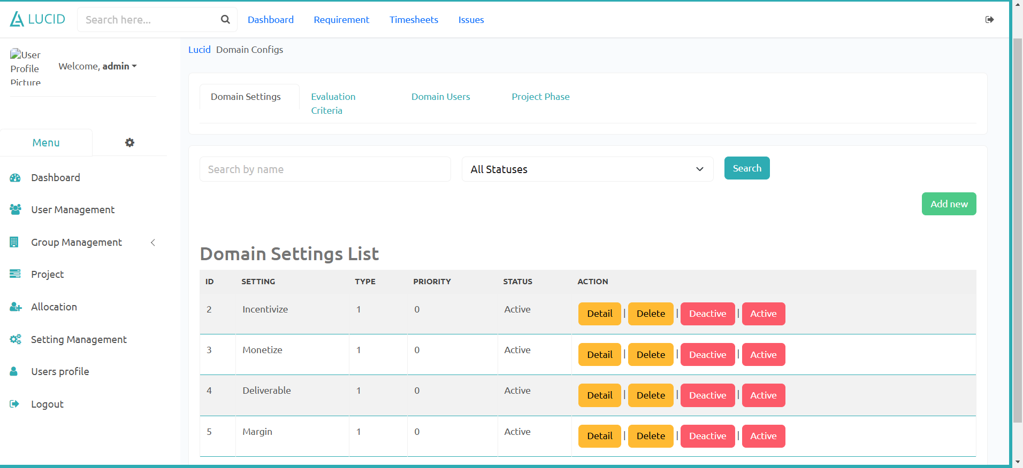

Add domain setting:

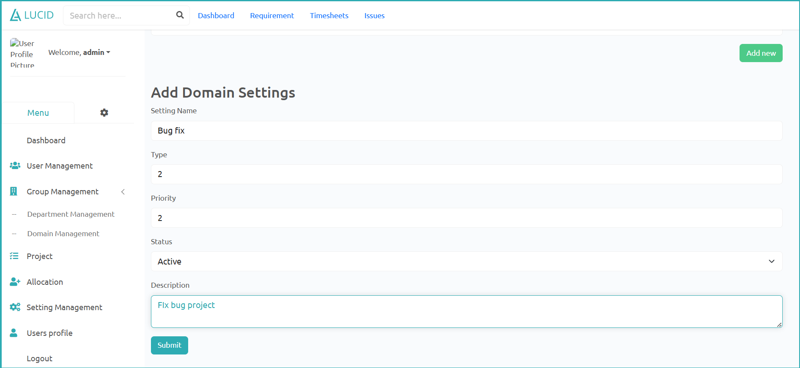

Edit domain Setting:

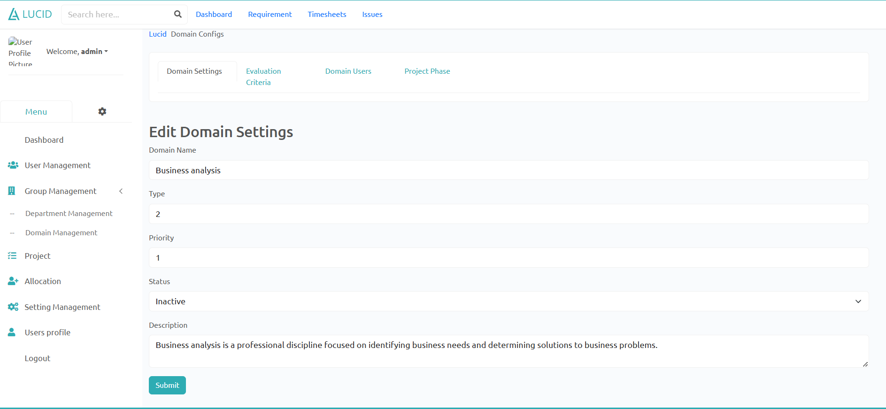

### 4.3. Domain criteria

Can Add,update,search domain criteria

## 

Add domain criteria

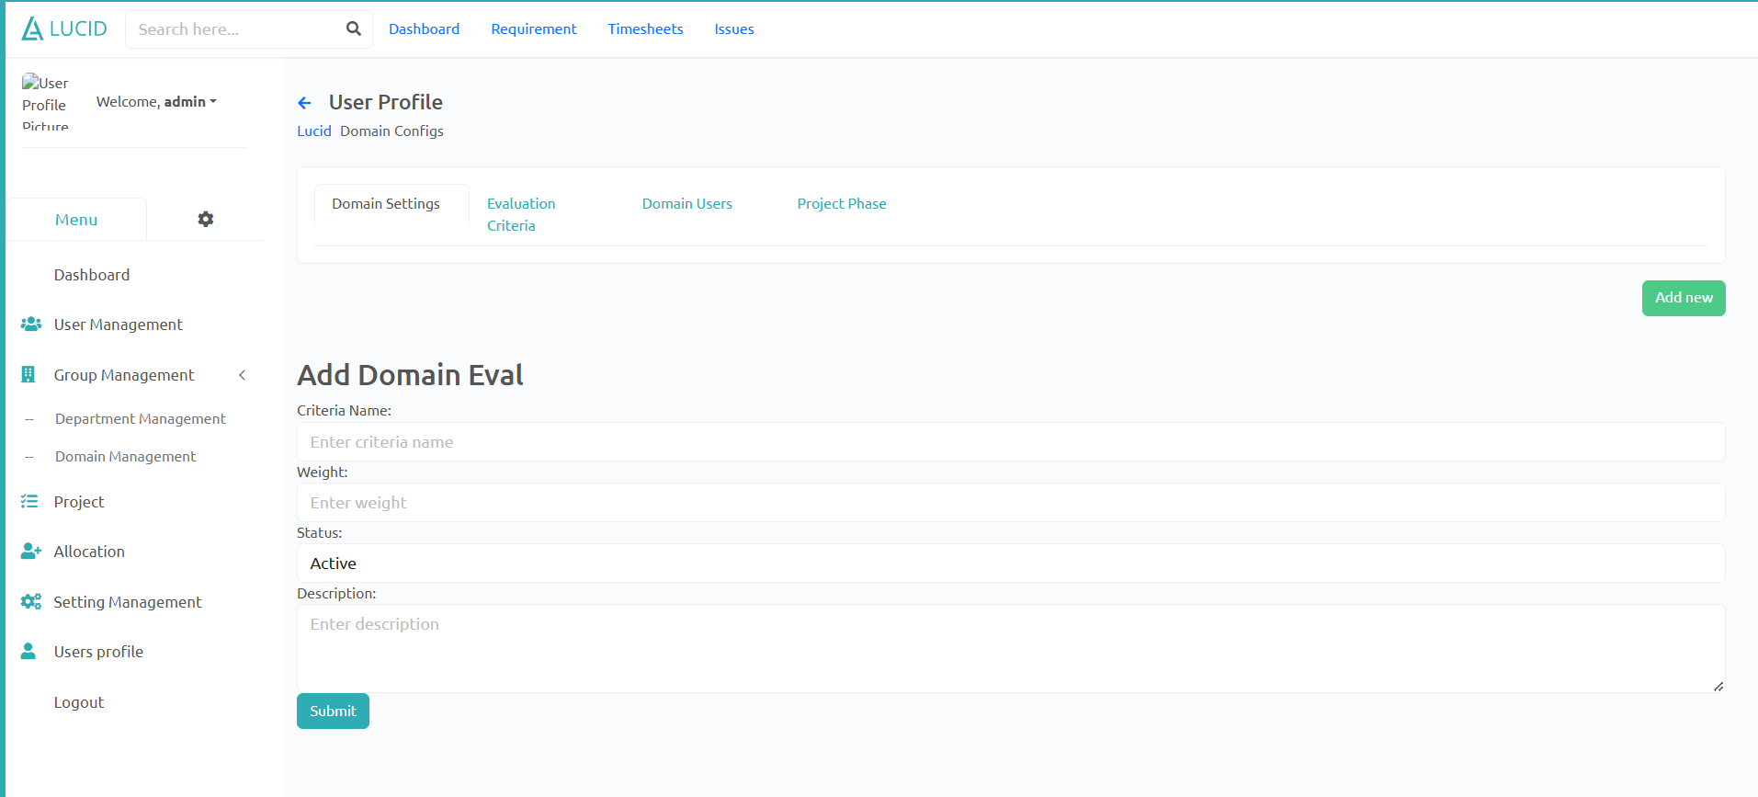

Edit domain criteria

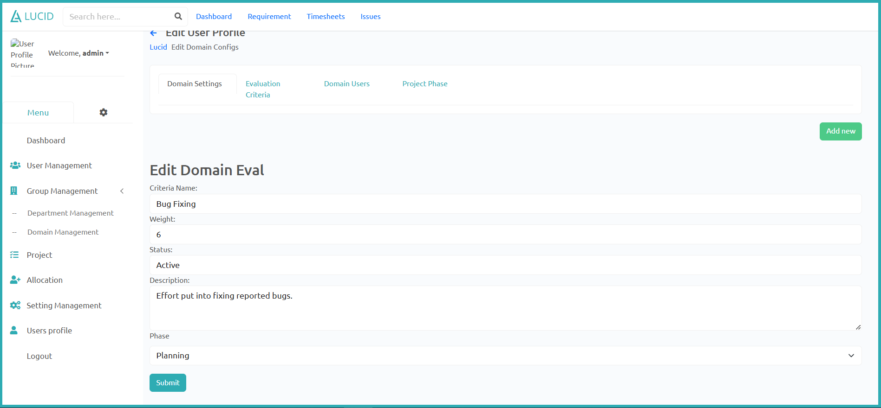

## 

### 4.4. Project Phase

4.4.1 Project Phase List

Show project phase of each domain, Add project phase, Delete project phase

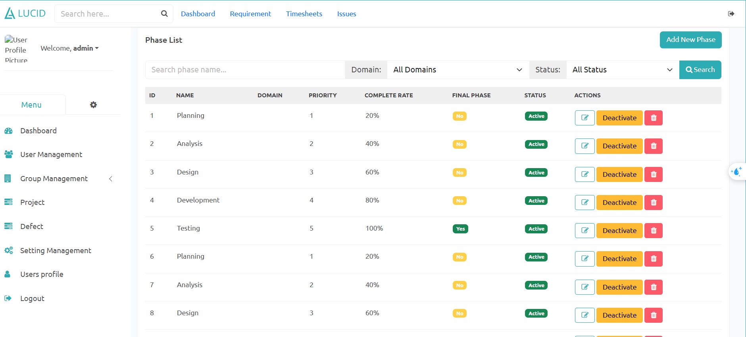

* Add Project Phase

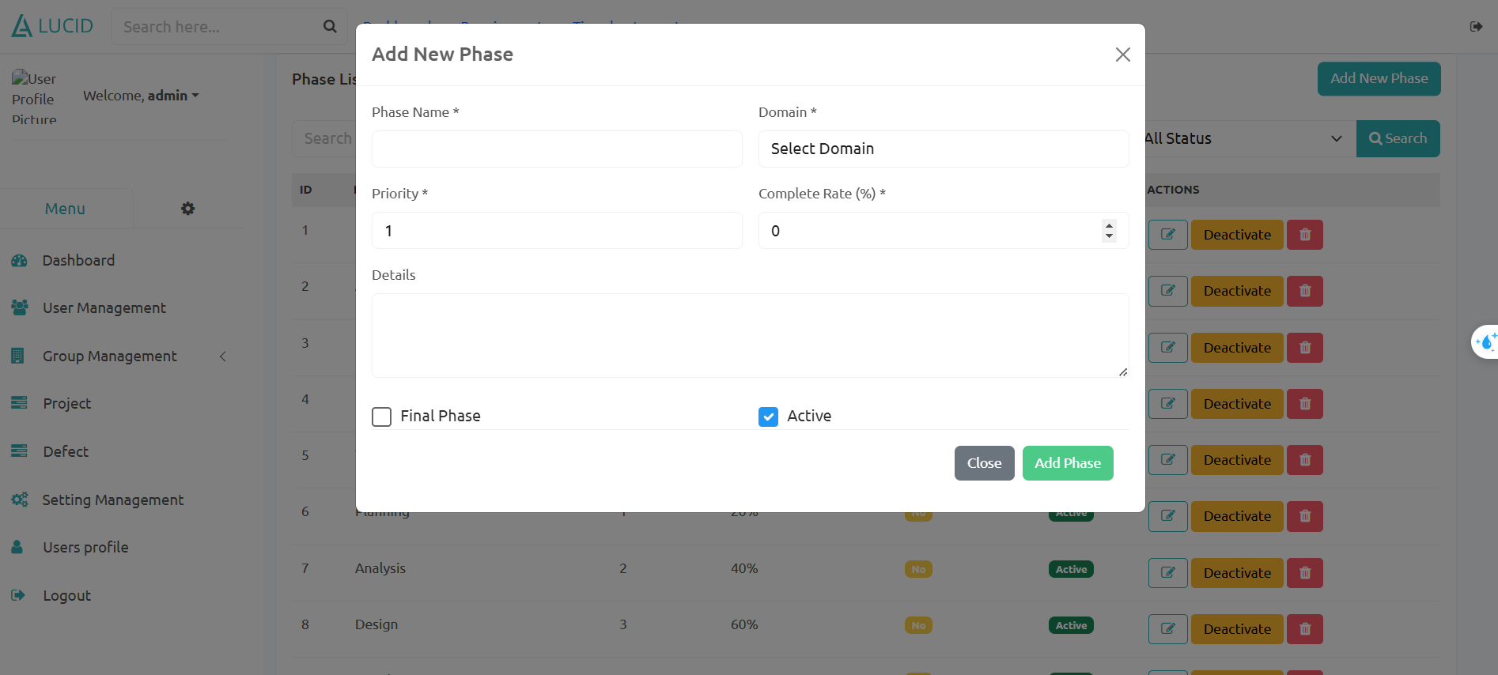

### 4.4.2 Project Phase Detail

Show detail project phase, Edit.

## 

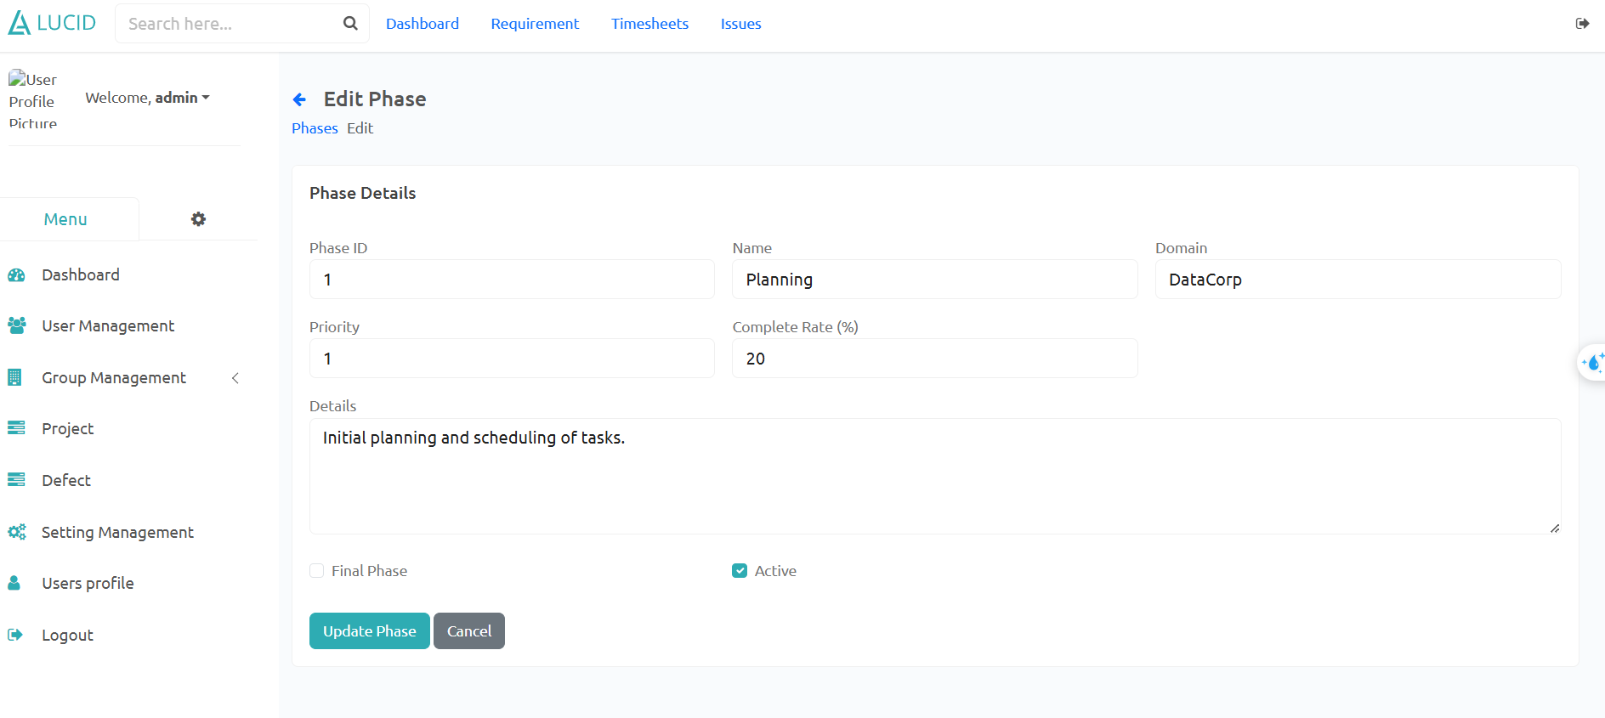

## 5. Department Manager Features

### 5.1. Allocation List + Details

Allocation List:

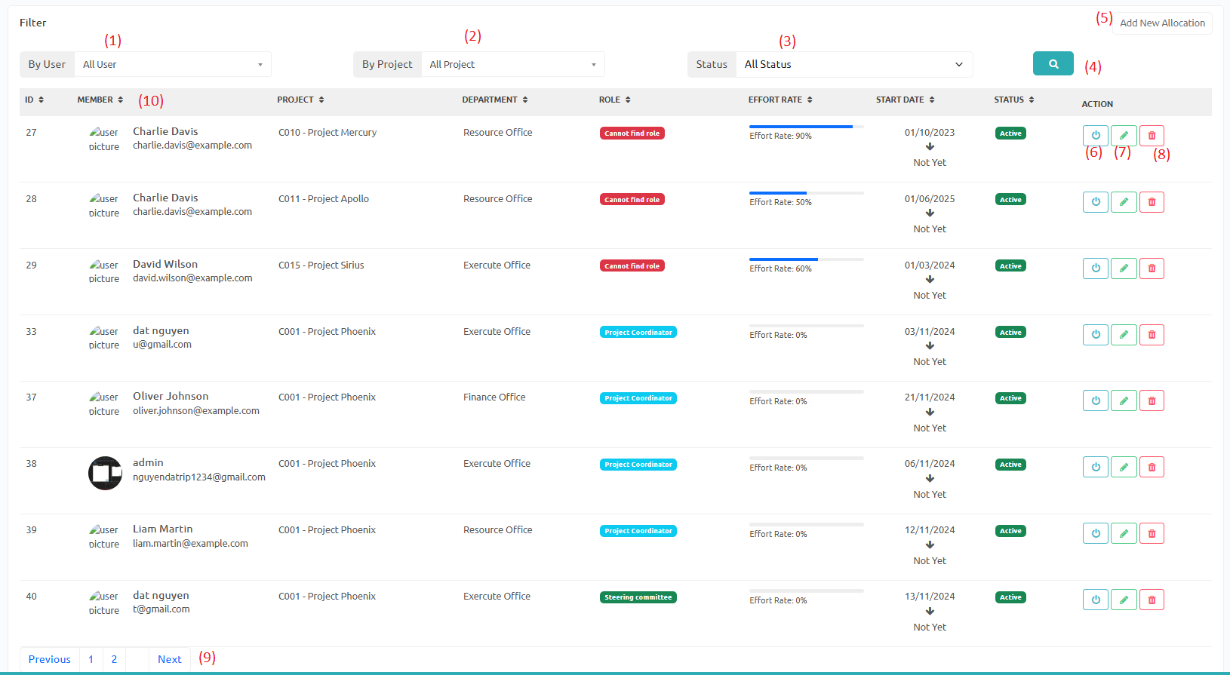

1. Filter allocations by user name.
2. Filter allocations by project.
3. Filter allocations by status.
4. Click to apply filters.
5. Open add new allocation modal.
6. Activate/Deactivate allocation status.
7. Open edit allocation modal.
8. Delete allocation.
9. Click Previous/Next or page number to change the page.
10. Click on table headers to sort.

Add allocation modal :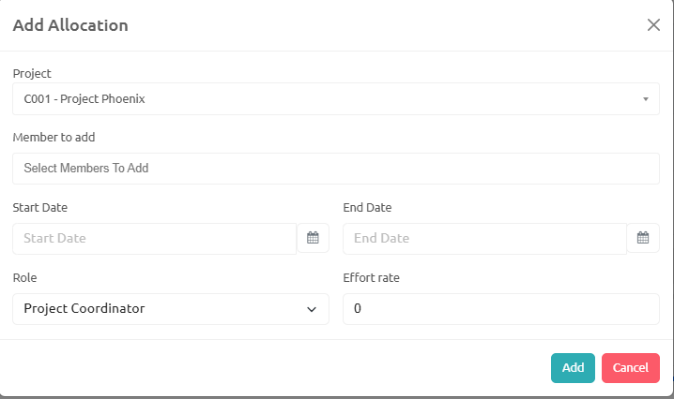

Update allocation modal:

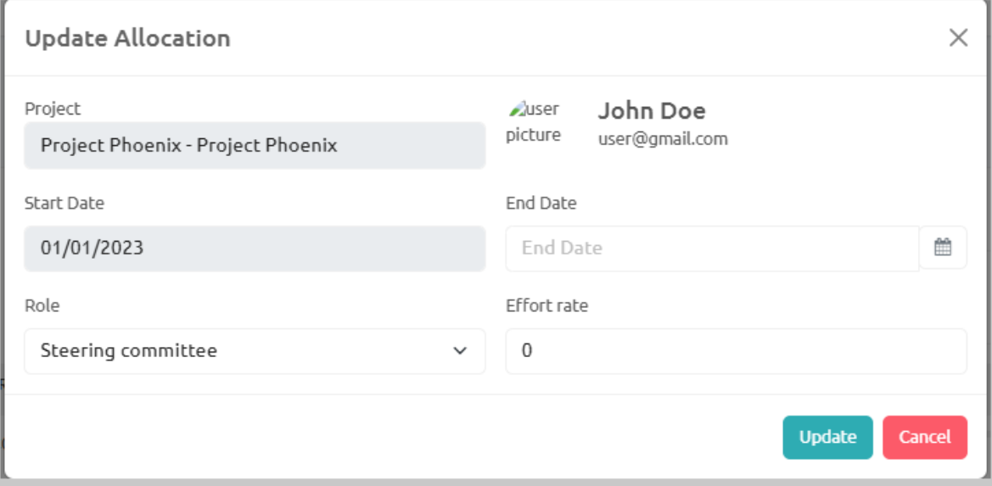

## 6. Member Feature

### 6.1. Project Issue

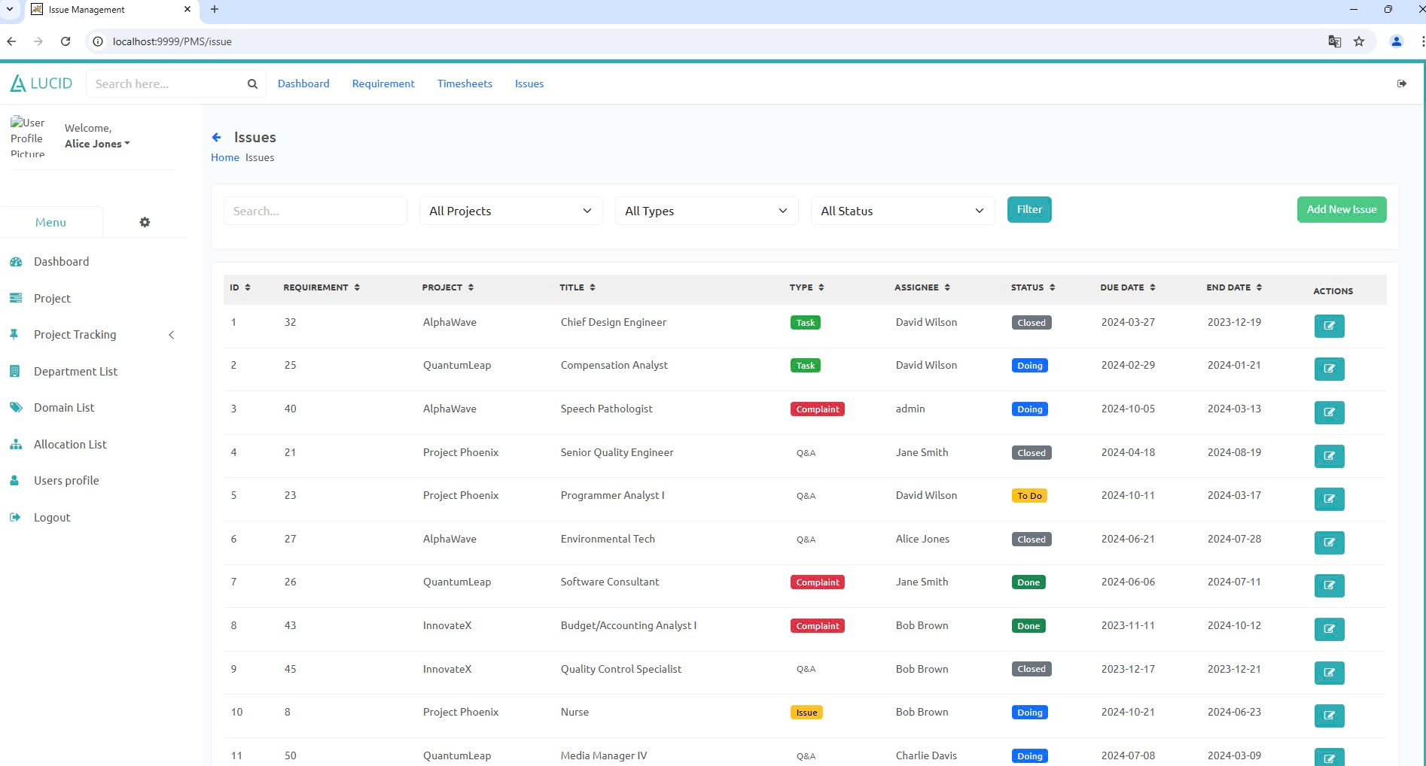



* Filter allocations by Project.
* Filter allocations by Type.
* Filter allocations by Status.
* Click to apply filters. flick to apply filters. f
* Open add new Issue.
* Input to search.
* Open edit Issue modal.
* Click Previous/Next or page number to change the page.
* Click on table headers to sort.

### 6.1.2 New Issue

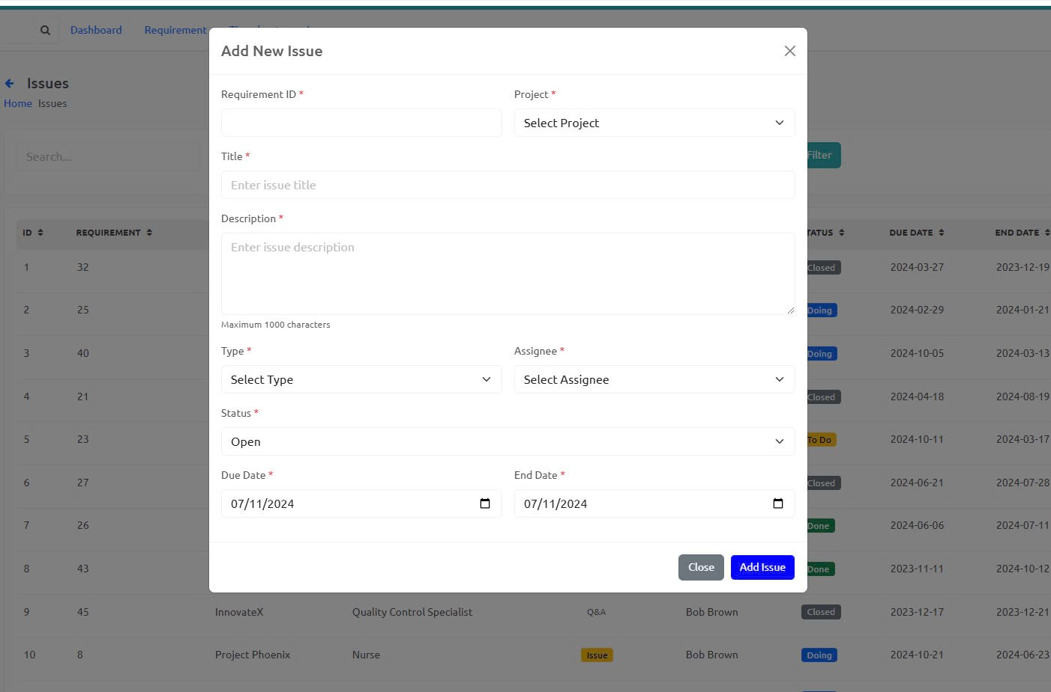

### 6.1.3 Issue Details

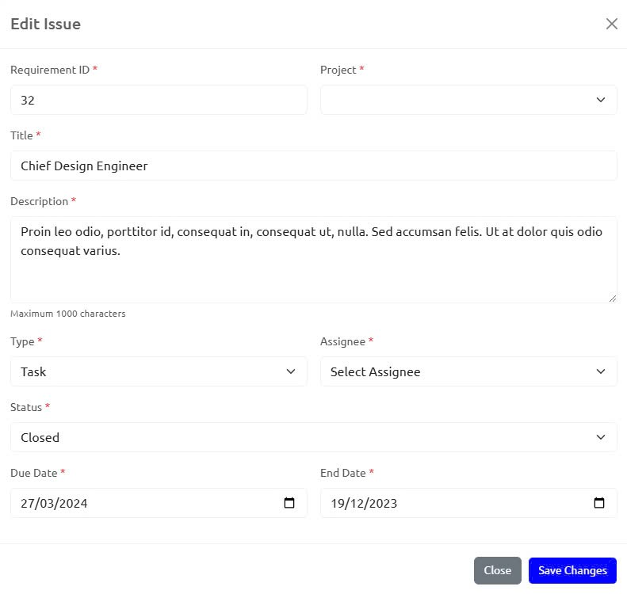

### 6.2. Project Defect

This screen will allow users to view defects in which they are personally involved.

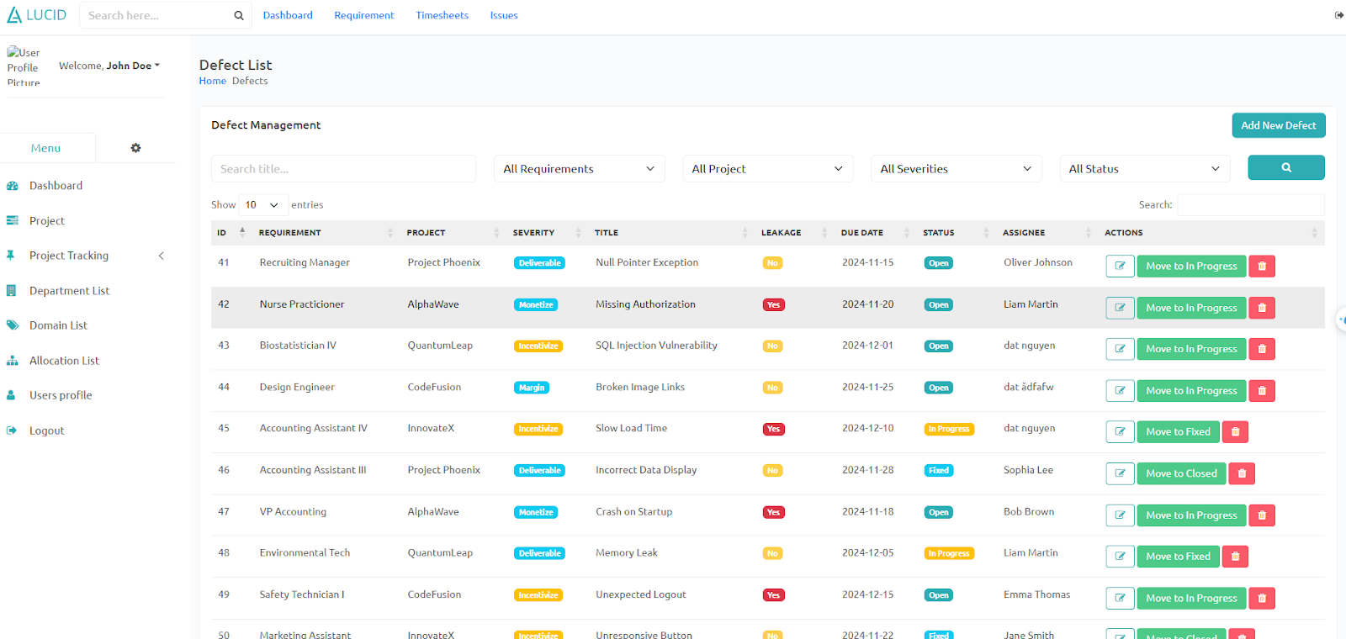

Admin, PMO can view all defects and members can only view their defects.

### 6.3. Defect New

Users can add defects, members can only add their own defects, and other roles can add for all users

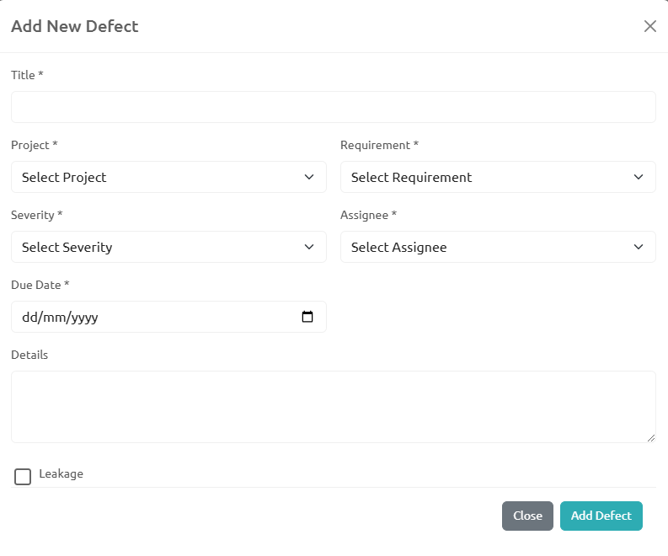

### 6.4. Defect Detail

Shows each component of the defect in detail and can be edited

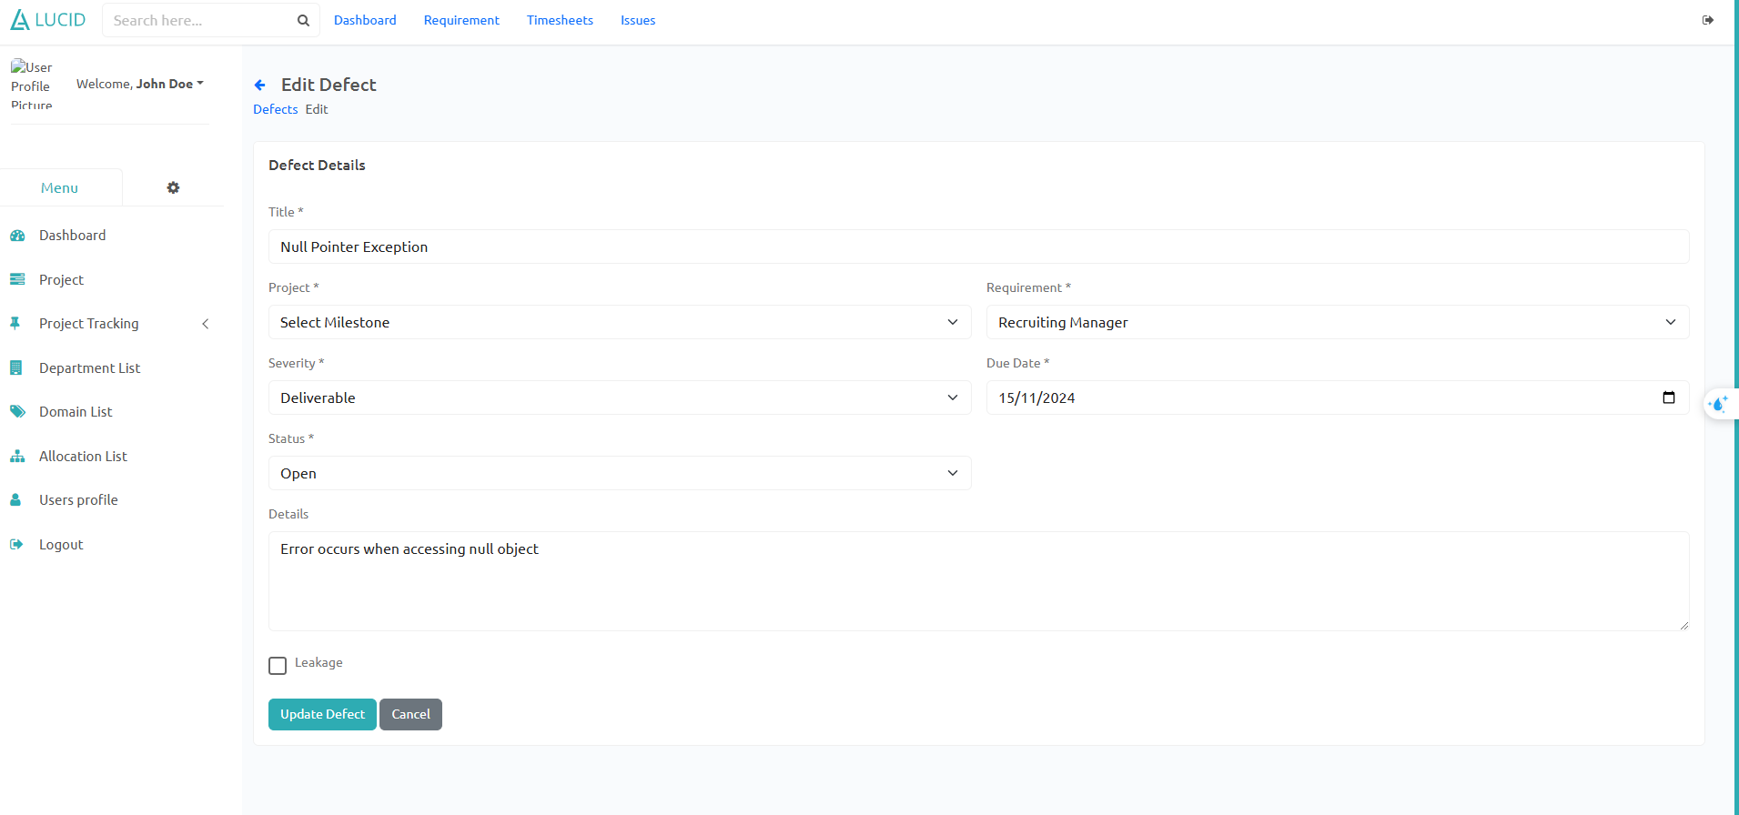

### 6.5. Requirement

1-Requirement list:

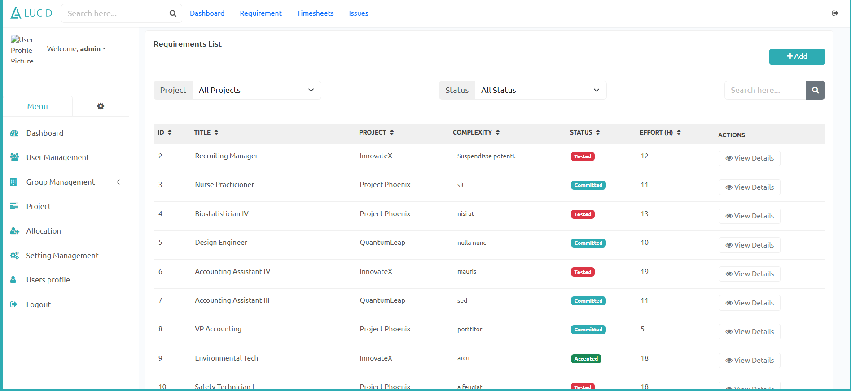

-Sort by id,project name,user name,detail,complexity,status

-Click add button to add new requirement

-CLick view detail to update information

-Click status to change status

Add Requirement modal :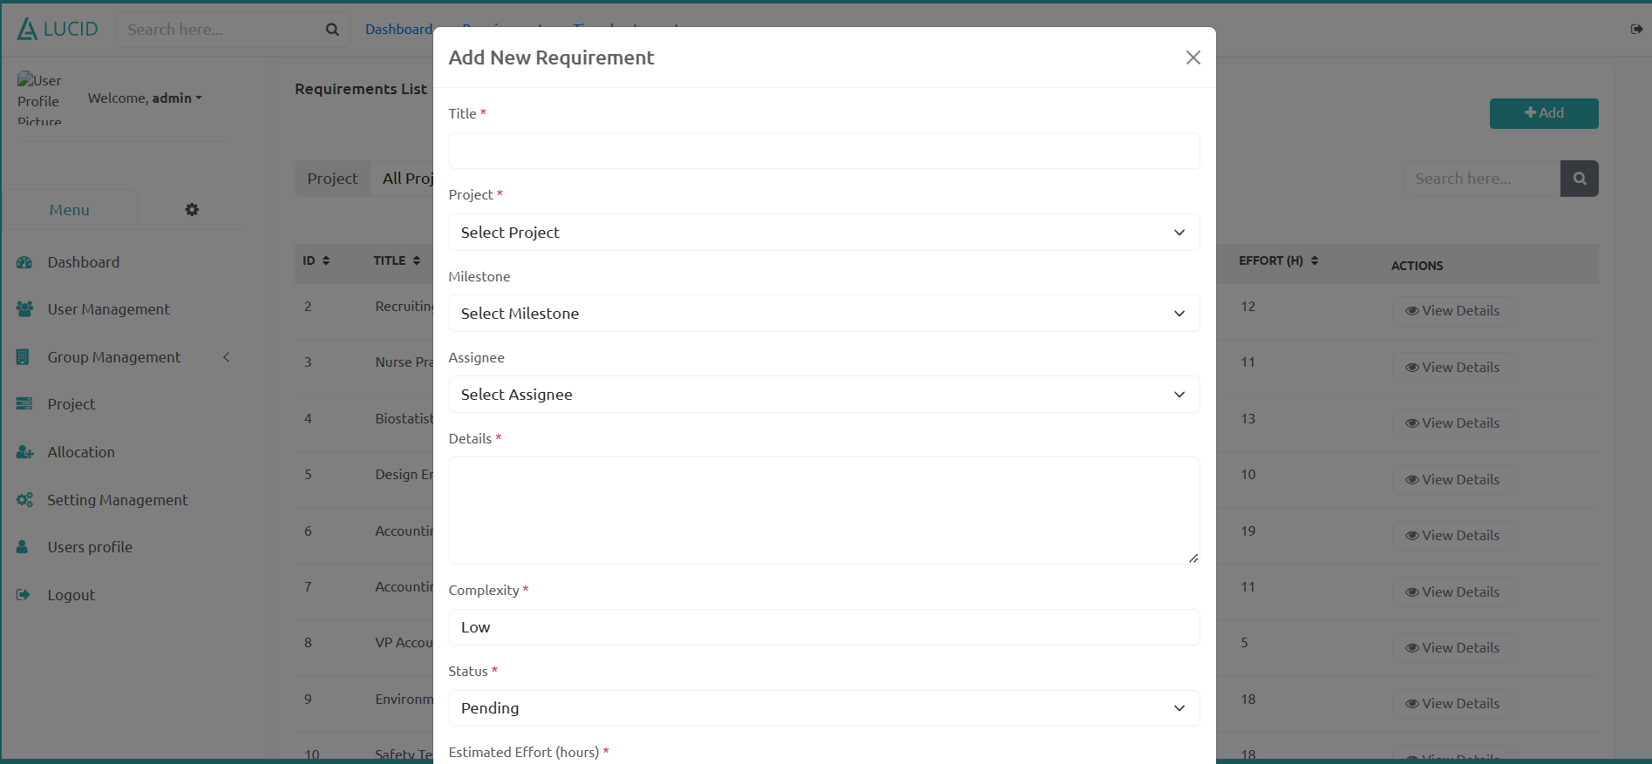

Update Requirement modal :Only Team Leader and PM can update requirements.

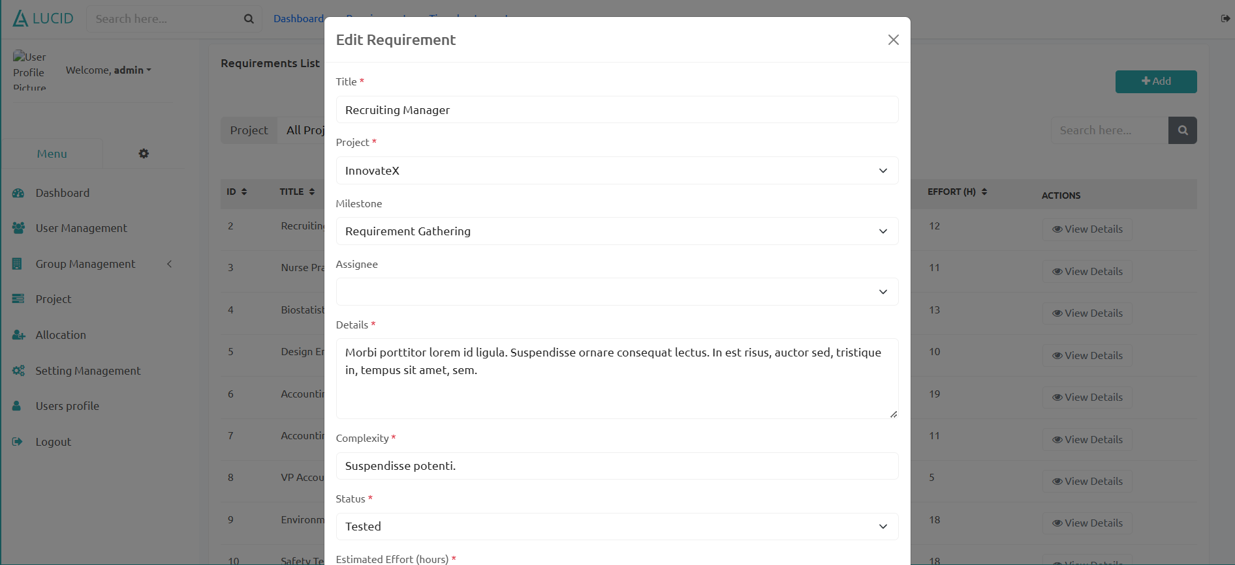

### 6.6. Timesheet

### 6.6.1 Timesheet List

-Sort by id,reporter,reviewer,project,requirement,startdate,enddate,status

-Click add button to add new timesheet(reviewer can not chose reviewer in form add, member can not chose member inform add,when creating new timesheet,the default status is submitted.)

-CLick view detail to update information

-Click status to change status(Member can only change status daft and subbited,QA,PMO,Project manager can change to approved and rejected)

-Click export to export to excel

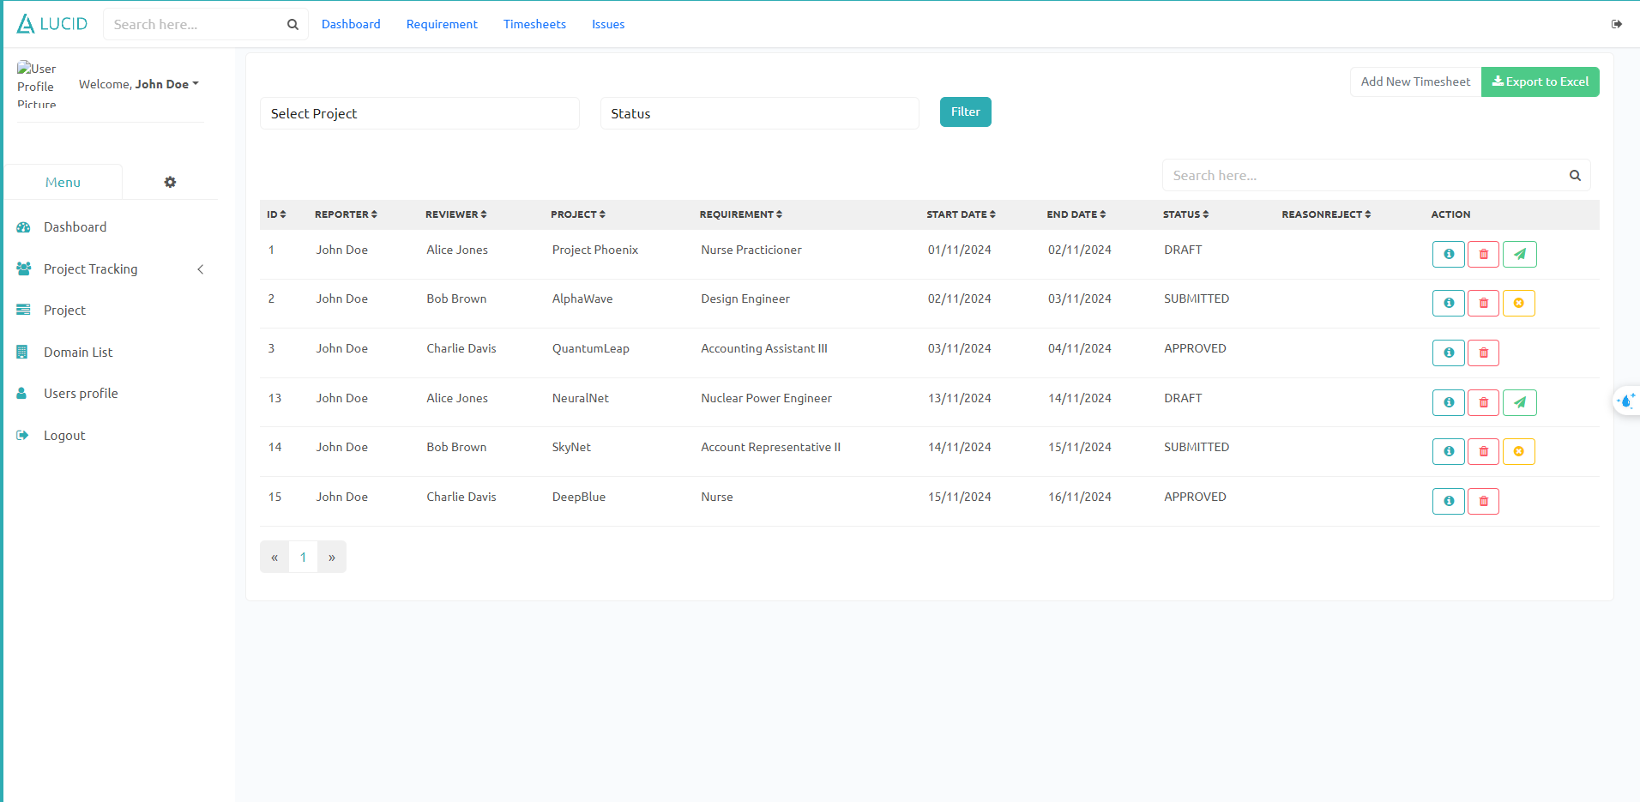

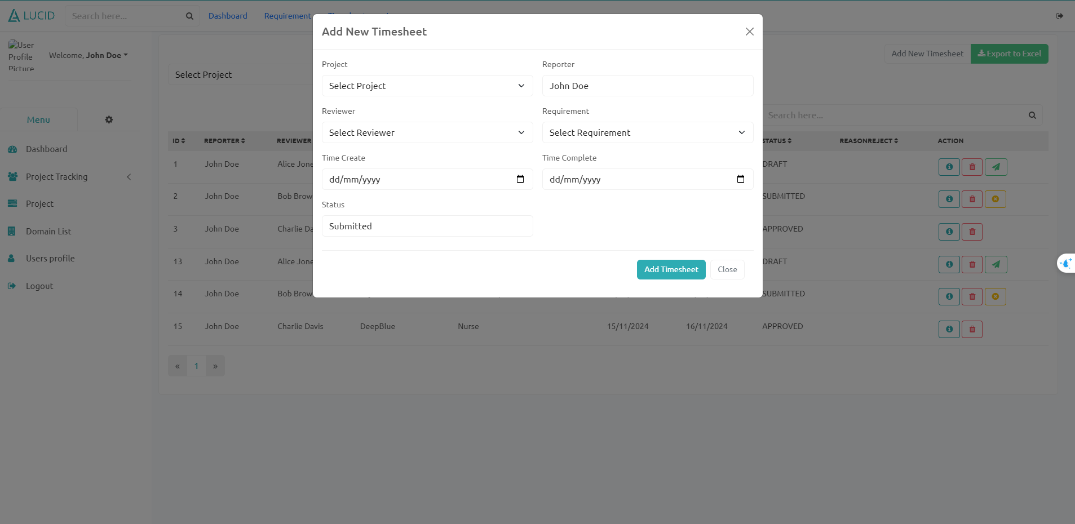

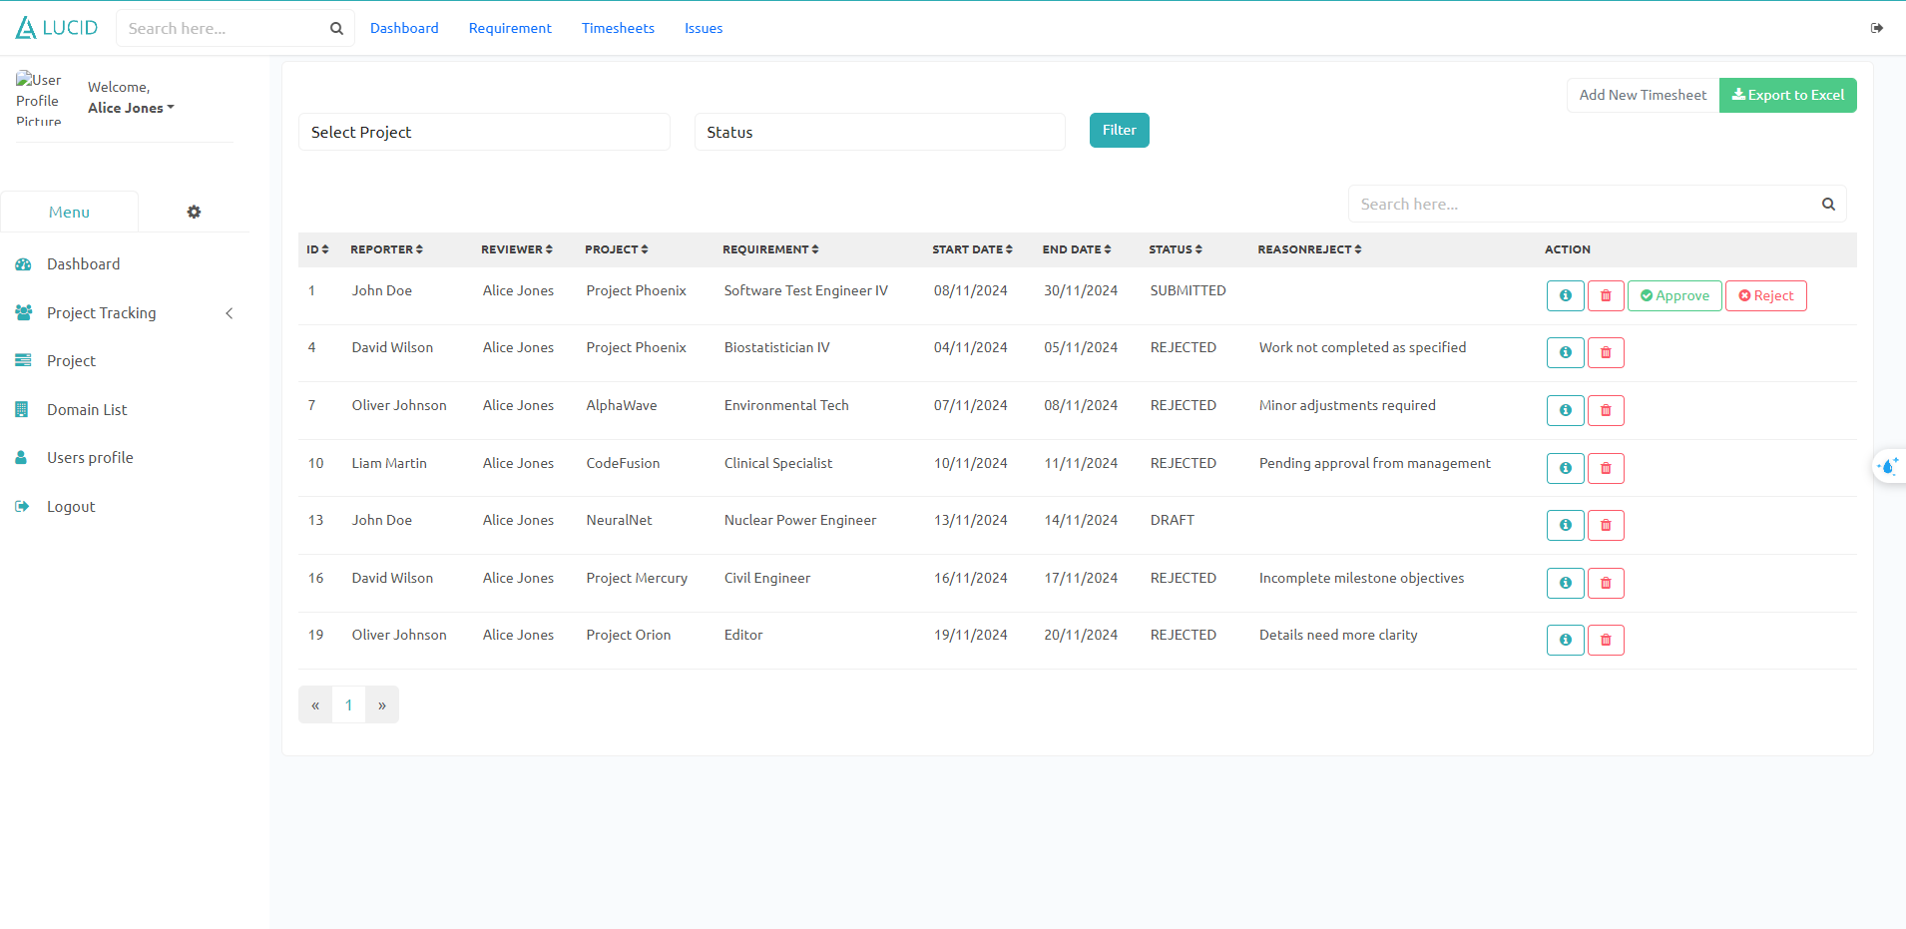

### 6.6.2 Timesheet detail

show information of each timesheet

member can only change information when status is draft or rejected

dept,PMO,project manager can change with any status.

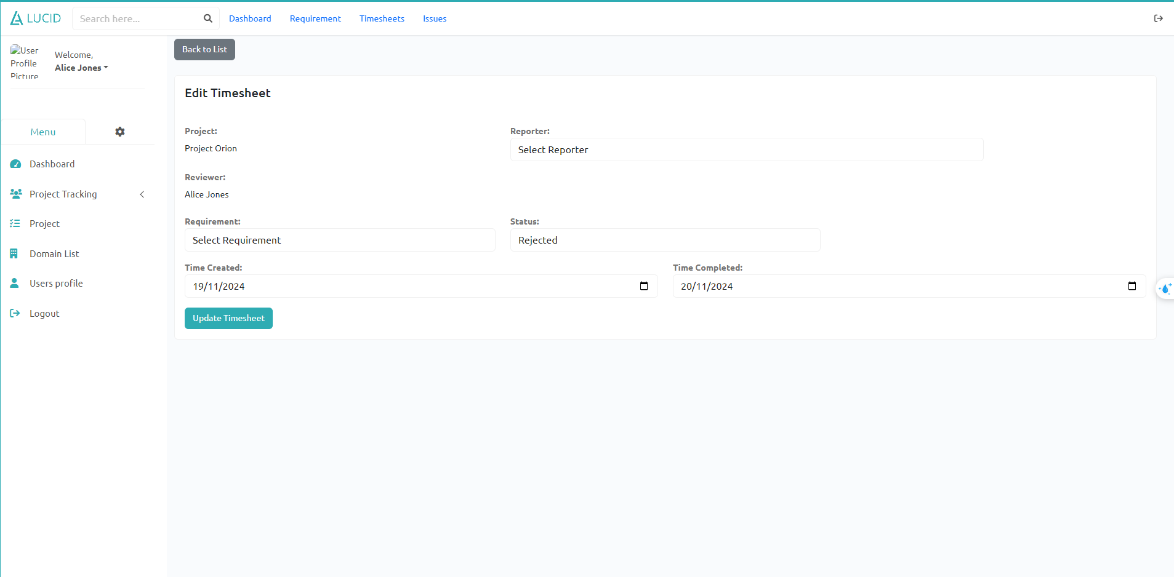

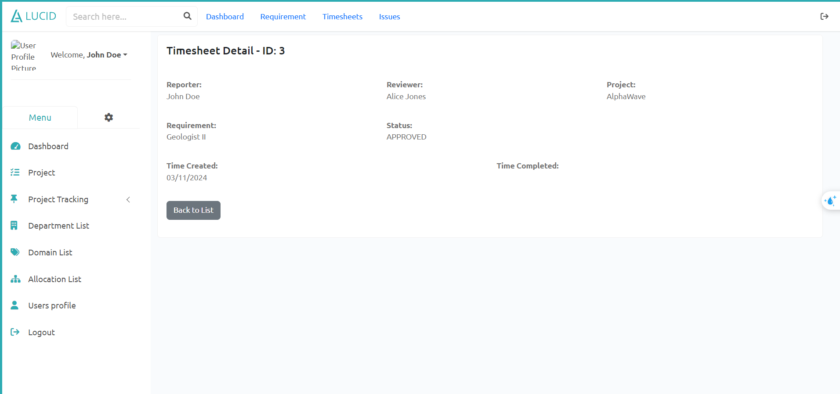

## III. System Design

## 1. Database Design

### 1.1 Database Schema

### 

### 

### 

### 

### 1.2 Table Descriptions

| **No** | **Table** | **Description** |
| --- | --- | --- |
| 01 | user | Use to store users informations  - Primary keys: id  - Foreign keys: departmentId  - Unique keys: email |
| 02 | group | Use to store Group informations  - Primary keys: id  - Unique keys: code, name |
| 03 | project | Use to store projects informations  - Primary keys: id  - Foreign keys: departmentId, domainId  - Unique keys: code, name |
| 04 | milestone | Use to store project’s milestones informations  - Primary key: id  - Foreign keys: projectId, PhaseId |
| 05 | team | Use to store teams informations  - Primary keys: id  - Foreign keys: projectId, leader  - Unique keys: name |
| 06 | setting | Use to store setting informations  - Primary keys: id, type |
| 07 | allocation | Use to store allocated projects for users  - Primary keys: userId, projectId  - Foreign keys: userId, projectId |
| 08 | department_manager | User to store user ID for managers of departments  - Primary keys: managerId, departmentId  - Foreign keys: managerId, departmentId |
| 09 | domain_user | User to store user ID for managers of domains  - Primary keys: userId, domainId  - Foreign keys: userId, domainId |
| 10 | project_criteria | Use to store project’s criteria informations  - Primary key: id  - Foreign keys: projectId, milestoneId |
| 11 | team_member | Use to store team’s members informations  - Primary key: id  - Foreign keys: userId, teamId |
| 12 | projectphase_criteria | Use to store each project phase criteria informations  - Primary key: id  - Foreign keys: phaseId |
| 13 | domain_setting | Use to store domain’s setting informations  - Primary key: id  - Foreign keys: domainId |
| 14 | defect | Use to store each defect informations  - Primary key: id  - Foreign keys: requirementId, projectId, serverityId |
| 15 | issue | Use to store each issue informations  - Primary key: id  - Foreign keys: requirementId, projectId, typeId, assigneeId |
| 16 | timesheet | Use to store each timesheet informations  - Primary key: id  - Foreign keys: requirementId, projectId, reporter, reviewer |
| 17 | requirement | Use to store each requirement informations  - Primary key: id  - Foreign keys: userId, projectId |

## 2. Code Packages

### 2.1 Package Diagram

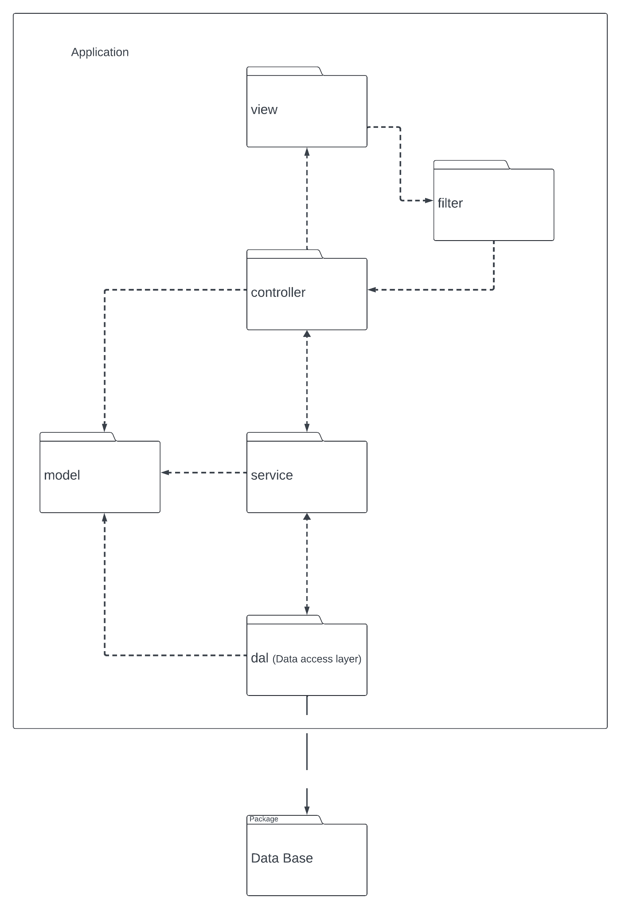

### 2.2 Package Descriptions

| **No** | **Package** | **Description** |
| --- | --- | --- |
| 01 | view | Contains web pages |
| 02 | filter | Contain filter classes that used to intercept the client request and do some pre-processing |
| 03 | controller | Contains classes that handle user’s requests  **Classes’s name: ClassNameController** |
| 04 | service | Contains classes that are used to perform business logic and communicate with database and controller  **Classes’s name: ClassNameService** |
| 05 | dal(Data access layer) | Contains classes that communicate with the database and return data to service  **Classes’s name: ClassnameDAO** |
| 06 | model | Contains classes that represent real entities in database  **Classes’ name: ClassName, …** |